

# YOUR ACCESS TO PSHE ASSOCIATION MATERIALS AND INTELLECTUAL PROPERTY RIGHTS

PSHE education is the school curriculum subject designed to keep children and young people safe, healthy and prepared for life, and work, in modern Britain. The best PSHE education is a partnership between parents/carers and schools — and this includes transparency regarding curriculum content and materials.

We are therefore delighted to provide parent/carer copies of all PSHE Association member materials that cover RSE (Relationships and Sex Education).

This is an example of such a resource. It has been shared with you as a parent/carer by the school or individual who is a PSHE Association member.

We are happy to grant access on this basis of giving you full, personal access to the resource contents, but appreciate your adherence to the following requirements regarding intellectual property rights given the resource is otherwise only accessible to schools and individuals that subscribe to PSHE Association membership.

# INTELLECTUAL PROPERTY RIGHTS

We are the owner or the licensee of all intellectual property rights in the materials. These works are protected by copyright laws and treaties around the world. All such rights are reserved.

You may print off one copy, and may download extracts, of any page(s) for your personal use as a parent/carer of a pupil at your child’s school.

You must not modify the paper or digital copies of any materials you have printed off or downloaded in any way, and you must not use any illustrations, photographs, video or audio sequences or any graphics separately from any accompanying text.

Our status (and that of any identified contributors) as the authors of the materials must always be acknowledged. You must not use any part of the materials for commercial purposes without obtaining a licence to do so from us or our licensors.

You are not permitted to copy, share — electronically (including social media) or otherwise — any part of our materials in breach of these terms of use. Your right to use such materials will cease immediately upon such a breach and you must, at our option, return or destroy any copies of the materials you have made.

Copyright © PSHE Association 2023

**Lesson plans**

**..................................................**

**Lesson 1:**

**Time to change**

**............................................**

**Lesson 2:**

**REMOVED**

**Lesson 3:**

**Personal hygiene**

**........................................**

**Lesson 4:**

**Emotions and feelings**

**...............................**

**Resources**

**...........................................................**

**Lesson 1**

**.........................................................................**

**Lesson 2**

**.........REMOVED...................................**

**Lesson 3**

**........................................................................**

**Lesson 4**

**........................................................................**

**2**

**2**

**6**

**11**

**16**

**20**

**20**

**26**

**31**

**33**

**Changing and growing up**

Lesson plans and resources for Year 4-5

**MEDWAY PUBLIC HEALTH DIRECTORATE**

**Parent/Carer copy (for personal use, not to be shared).**

**Copyright © PSHE Association 2023**

**Parent/Carer copy (for personal use, not to be shared).**

**Copyright © PSHE Association 2023**

# Lesson 1: Time to change KS2 Year 4-5

dŚŝƐŝƐƚŚĞĮƌƐƚŽĨĨŽƵƌůĞƐƐŽŶƐĞǆƉůŽƌŝŶŐƉƵďĞƌƚǇ͕ĨŽƌŬĞǇƐƚĂŐĞϮƉƵƉŝůƐŝŶzĞĂƌϰŽƌzĞĂƌϱ͘dŚŝƐůĞƐƐŽŶŝŶƚƌŽĚƵĐĞƐ ƚŚĞĐŽŶĐĞƉƚŽĨƉƵďĞƌƚǇĂŶĚĞǆƉůŽƌĞƐƐŽŵĞĞǆƚĞƌŶĂůĐŚĂŶŐĞƐƚŚĂƚŚĂƉƉĞŶƚŽƚŚĞďŽĚǇ͕ĂƐǁĞůůĂƐƐƵƉƉŽƌƟŶŐ

ƉƵƉŝůƐƚŽŝĚĞŶƟĨǇĂŶĚůĂďĞůŬĞǇďŽĚǇƉĂƌƚƐ͘

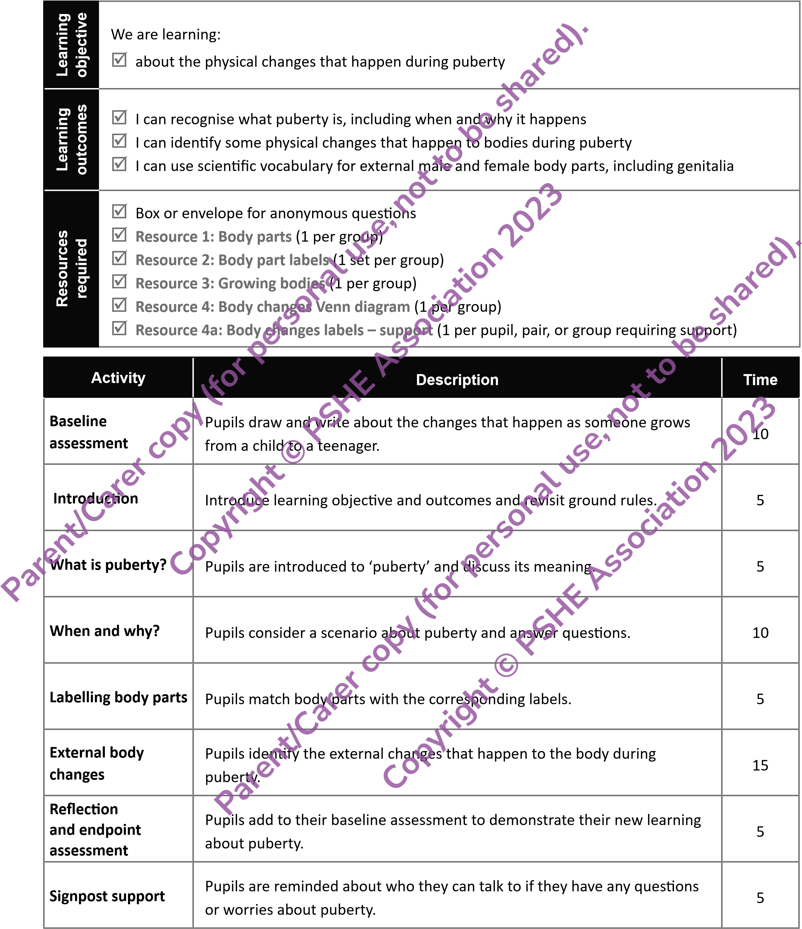

|  |  |  |
| --- | --- | --- |
| **Climate for**  **learning** | **Make sure you have read the accompanying teacher guidance notes before teaching this lesson.** dŚĞƐĞŝŶĐůƵĚĞŐƵŝĚĂŶĐĞŽŶŐƌŽƵŶĚƌƵůĞƐ͕ƚŚĞůŝŵŝƚƐŽĨĐŽŶĮĚĞŶƟĂůŝƚǇ͕ƌĞůĞǀĂŶƚƐƵďũĞĐƚŬŶŽǁůĞĚŐĞ͕ ĐŽŵŵƵŶŝĐĂƟŽŶ͕ĂŶĚŚĂŶĚůŝŶŐƋƵĞƐƟŽŶƐĞīĞĐƟǀĞůǇ͘/ĨĂŶǇƐĂĨĞŐƵĂƌĚŝŶŐĐŽŶĐĞƌŶƐĂƌŝƐĞŝŶƚŚŝƐůĞƐƐŽŶ͕ ƚŚĞƐĞƐŚŽƵůĚďĞƌĞƉŽƌƚĞĚƚŽƚŚĞĞƐŝŐŶĂƚĞĚ^ĂĨĞŐƵĂƌĚŝŶŐ>ĞĂĚ͘ | |
| **Key**  **words** | ƉƵďĞƌƚǇ͕ĐŚĂŶŐĞ͕ŐƌŽǁ͕ŵĂƚƵƌĞ͕ĐŚŝůĚ͕ƚĞĞŶĂŐĞ͕ĂĚƵůƚ͕ŚŽƌŵŽŶĞƐ͕ŐĞŶŝƚĂůƐ͕ǀƵůǀĂ͕ǀĂŐŝŶĂ͕ƉĞŶŝƐ͕ ƚĞƐƟĐůĞƐ͕ďƌĞĂƐƚƐ͕ƉƵďŝĐŚĂŝƌ͕ĚĂŵ͛ƐĂƉƉůĞ͕ůĂƌǇŶǆ;͚ǀŽŝĐĞďŽǆ͛Ϳ | |
| **Baseline assessment** | **Baseline assessment activity** | **10 mins**  **shared).** |
| ƐŬƉƵƉŝůƐƚŽĚƌĂǁƚǁŽƋƵŝĐŬƉŝĐƚƵƌĞƐͲŽŶĞŽĨĂŵĂůĞĐŚŝůĚĂŶĚŽŶĞŽĨĂĨĞŵĂůĞĐŚŝůĚƚŚĞƐĂŵĞĂŐĞĂƐ ƚŚĞŵ͘EŽǁĂƐŬƚŚĞŵƚŽƚŚŝŶŬĂďŽƵƚƚŚĞĐŚĂŶŐĞƐƚŚĂƚǁŝůůŚĂƉƉĞŶƚŽƚŚĞĐŚŝůĚƌĞŶĂƐƚŚĞǇĚĞǀĞůŽƉŝŶƚŽ ƚĞĞŶĂŐĞƌƐ͕ǁƌŝƟŶŐŽƌĚƌĂǁŝŶŐƚŚĞĐŚĂŶŐĞƐĂƌŽƵŶĚƚŚĞŝƌƉŝĐƚƵƌĞ͘hƐĞƚŚĞĨŽůůŽǁŝŶŐƋƵĞƐƟŽŶƐƚŽŐƵŝĚĞ pupils:  **copy**  **(**  **for**  **personal**  **use,**  **not**  **to**  **be**    **©**  **PSHE**  **Association**  **2023**        **use,**  **not**  **to**  **be**  **shared).**  **2023**   * tŚĂƚƉŚǇƐŝĐĂůĂŶĚĞŵŽƟŽŶĂůĐŚĂŶŐĞƐŵŝŐŚƚŚĂƉƉĞŶ͍ * tŚĂƚŵŝŐŚƚƚŚĞǇďĞĂďůĞƚŽĚŽǁŚĞŶƚŚĞǇĂƌĞŽůĚĞƌ͍ * tŚĂƚŽƚŚĞƌĐŚĂŶŐĞƐŵŝŐŚƚŚĂƉƉĞŶ͍   WƵƉŝůƐǁŽƌŬŝŶĚŝǀŝĚƵĂůůǇĂŶĚǁŝƚŚŽƵƚƉƌŽŵƉƟŶŐ͘ZĞŵŝŶĚƚŚĞŵƚŚĂƚĚƌĂǁŝŶŐĂďŝůŝƚǇĂŶĚƐƉĞůůŝŶŐƐ  ĚŽŶ͛ƚŵĂƩĞƌ͕ǇŽƵĂƌĞũƵƐƚŝŶƚĞƌĞƐƚĞĚŝŶƚŚĞŝƌŝŶŝƟĂůŝĚĞĂƐĂďŽƵƚĐŚĂŶŐŝŶŐĂŶĚŐƌŽǁŝŶŐ͘ŝƌĐƵůĂƚĞǁŚŝůƐƚ  ƉƵƉŝůƐĂƌĞǁŽƌŬŝŶŐƚŽŐĂƵŐĞƚŚĞŝƌĞǆŝƐƟŶŐŬŶŽǁůĞĚŐĞ͕ƵŶĚĞƌƐƚĂŶĚŝŶŐĂŶĚĂƫƚƵĚĞƐĂďŽƵƚƉƵďĞƌƚǇ͕ ĂƐǁĞůůĂƐĂŶǇŵŝƐĐŽŶĐĞƉƟŽŶƐĂŶĚŐĂƉƐŝŶƵŶĚĞƌƐƚĂŶĚŝŶŐ͘ŌĞƌǁĂƌĚƐ͕ĐŽůůĞĐƚƚŚĞƉƵƉŝůƐ͛ǁŽƌŬŝŶƚŽ ƌĞǀŝĞǁŝŶŵŽƌĞĚĞƚĂŝůƚŽŝŶĨŽƌŵĨƵƚƵƌĞůĞƐƐŽŶƐ͘WƵƉŝůƐǁŝůůĂůƐŽƌĞǀŝƐŝƚƚŚĞŵĂƚƚŚĞĞŶĚŽĨƚŚĞƵŶŝƚŽĨ ǁŽƌŬŽŶƉƵďĞƌƚǇƚŽĚĞŵŽŶƐƚƌĂƚĞƚŚĞŝƌůĞĂƌŶŝŶŐĂŶĚƉƌŽŐƌĞƐƐ͘ | |
| **Introduction 10 mins**  **Copyright**  /ŶƚƌŽĚƵĐĞƚŚĞůĞĂƌŶŝŶŐŽďũĞĐƟǀĞĂŶĚŽƵƚĐŽŵĞƐ͘ǆƉůĂŝŶƚŚĂƚƚŽĚĂǇ  ͛ƐůĞƐƐŽŶǁŝůůĞǆƉůŽƌĞǁŚĂƚƉƵďĞƌƚǇ  ŝƐĂŶĚǁŚĂƚĐĂƵƐĞƐŝƚ͕ĂƐǁĞůůĂƐŝĚĞŶƟĨǇŝŶŐŚŽǁďŽĚŝĞƐĐŚĂŶŐĞĚƵƌŝŶŐƉƵďĞƌƚǇ͘  hƐŝŶŐƐůŝĚĞϱ͕ĚŝƐĐƵƐƐƚŚĞŵĞĂŶŝŶŐŽĨƉƵďĞƌƚǇĂƐĂĐůĂƐƐĂŶĚŐĂƚŚĞƌƉƵƉŝůƐ͛ŝĚĞĂƐ͕ĞŶƐƵƌŝŶŐƚŚĂƚƚŚĞǇ  ŬŶŽǁƚŚĂƚƉƵďĞƌƚǇƌĞůĂƚĞƐƚŽĐŚĂŶŐŝŶŐ͕ŐƌŽǁŝŶŐ͕ĂŶĚŵĂƚƵƌŝŶŐĨƌŽŵĂĐŚŝůĚƚŽĂŶĂĚƵůƚ͘  **Challenge:**  WƵƉŝůƐĐƌĞĂƚĞĂĚĞĮŶŝƟŽŶŽĨƉƵďĞƌƚǇ͘&ŽƌĞǆĂŵƉůĞ͕ƉƵďĞƌƚǇŝƐǁŚĞŶĂƉĞƌ  ƐŽŶ͛ƐďŽĚǇƐƚĂƌƚƐ  ƚŽĐŚĂŶŐĞƉŚǇƐŝĐĂůůǇĂŶĚŵĞŶƚĂůůǇĨƌŽŵƚŚĂƚŽĨĂĐŚŝůĚƚŽĂŶĂĚƵůƚ͘    **copy**  **(**  **for**  **personal**    **©**  **PSHE**  **Association** | |
| **Core activities** | **When and why? 10 mins**  hƐŝŶŐƐůŝĚĞϲ͕ƐŚĂƌĞƚŚĞĨŽůůŽǁŝŶŐƐĐĞŶĂƌŝŽ͗  ƐŬƉƵƉŝůƐƚŽĚŝƐĐƵƐƐŝŶƉĂŝƌƐ͗  **Parent/Carer**  **Copyright**  *Layla has been learning about growing and changing at school. She has spoken to her older brother Joe about going through puberty and is wondering when it might happen to her. She asks Joe, ‘Why does puberty happen?”*   * tŚĞŶĐĂŶƉƵďĞƌƚǇƐƚĂƌƚ͍ * tŚĂƚĐŽƵůĚ:ŽĞƐĂǇƚŽ>ĂǇůĂ͍ | |

**Parent/Carer**

|  |  |
| --- | --- |
| **Core activities** | dĂŬĞĨĞĞĚďĂĐŬĂŶĚĚŝƐĐƵƐƐƉƵƉŝůƐ͛ƌĞƐƉŽŶƐĞƐĂƐĂĐůĂƐƐ͘ƌĂǁŽƵƚƚŚĞƉŽŝŶƚƐďĞůŽǁ͕ĐŽƌƌĞĐƚĂŶǇ ŵŝƐĐŽŶĐĞƉƟŽŶƐĂŶĚĂĚĚĨƵƌƚŚĞƌŝŶĨŽƌŵĂƟŽŶĂƐƌĞƋƵŝƌĞĚ͘   * *Between the ages of 8 and 18, most people will go through puberty. Signs of puberty might start at a young age for some people, some might start a bit later, and others will feel like it stops and starts with gaps in between.*   **shared).**   * *Puberty is caused by hormones - special chemicals produced by the brain. When puberty starts, hormones send messages to the body to start changing and developing into an adult.* |
| **Labelling body parts 5 mins**  /ŶƐŵĂůůŐƌŽƵƉƐ͕ŐŝǀĞƉƵƉŝůƐ**Resource 1: Body parts**ĂŶĚĂƐŬƚŚĞŵƚŽƚŚŝŶŬďĂĐŬƚŽƚŚĞŝƌůĞĂƌŶŝŶŐŝŶ  ŬĞǇƐƚĂŐĞϭĂŶĚŵĂƚĐŚƚŚĞďŽĚǇƉĂƌƚƐǁŝƚŚ**Resource 2: Body part labels**͘  >ĞƚƉƵƉŝůƐŬŶŽǁƚŚĂƚƚŚĞƌĞǁŝůůďĞƚǁŽůĂďĞůƐĨŽƌďŽĚǇƉĂƌƚƐƚŚĂƚĐĂŶŶŽƚďĞƐĞĞŶĚŝƌĞĐƚůǇŝŶƚŚĞ picture, but that they should draw an arrow to where the body parts would be if they could see ƚŚĞŵ͘  **for**  **personal**  **use,**  **not**  **to**  **be**    **Association**  **2023**    **to**  **be**  **shared).**  'ŽƚŚƌŽƵŐŚƚŚĞƉƵƉŝůƐ͛ƌĞƐƉŽŶƐĞƐƵƐŝŶŐƐůŝĚĞϴĂŶĚĐŽƌƌĞĐƚĂŶǇŵŝƐĐŽŶĐĞƉƟŽŶƐŽƌĞƌƌŽƌƐ͘ǆƉůĂŝŶƚŚĂƚ ƚŚĞǀƵůǀĂĂŶĚǀĂŐŝŶĂĐĂŶŶŽƚďĞƐĞĞŶĚŝƌĞĐƚůǇŝŶƚŚĞƉŝĐƚƵƌĞ͘dŚĞǀƵůǀĂŝƐƚŚĞŽƵƚĞƌƉĂƌƚŽĨƚŚĞĨĞŵĂůĞ  ŐĞŶŝƚĂůƐ͕ĂŶĂƌĞĂƚŚĂƚŝŶĐůƵĚĞƐƚŚĞŽƉĞŶŝŶŐŽĨƚŚĞǀĂŐŝŶĂ͕ǁŚŝĐŚŝƚƐĞůĨŝƐĂŶŝŶƚĞƌŶĂůƉĂƌƚŽĨƚŚĞĨĞŵĂůĞ  ŐĞŶŝƚĂůƐ;ŝŶƐŝĚĞƚŚĞďŽĚǇͿ͘ |
| **Body changes 15 mins**  hƐŝŶŐ**Resource 3: Growing bodies**͕ŝŶƐŵĂůůŐƌŽƵƉƐ͕ĂƐŬƉƵƉŝůƐƚŽĚŝƐĐƵƐƐƚŚĞĐŚĂŶŐĞƐƚŚĞǇĐĂŶƐĞĞ ďĞƚǁĞĞŶƚŚĞďŽĚŝĞƐďĞĨŽƌĞĂŶĚĂŌĞƌƉƵďĞƌƚǇ͕ĂƐǁĞůůĂƐĂŶǇŽƚŚĞƌĐŚĂŶŐĞƐƚŚĞǇŚĂǀĞŚĞĂƌĚĂďŽƵƚŽƌ ŶŽƟĐĞĚĂƐƐŽŵĞŽŶĞŐƌŽǁƐƵƉ͘dŚĞǇƐŚŽƵůĚƌĞĐŽƌĚƚŚĞŝƌŝĚĞĂƐƵƐŝŶŐ**Resource 4: Body changes Venn diagram**͕ǁƌŝƟŶŐĂŶǇĐŚĂŶŐĞƐĨŽƌďŽƚŚĨĞŵĂůĞƐĂŶĚŵĂůĞƐŝŶƚŚĞŵŝĚĚůĞ͘ *Pupil responses might include:*  **copy**  **(**  **Copyright**  **©**  **PSHE**        **Parent/Carer**  **copy**  **(**  **for**  **personal**  **use,**  **not**    **Copyright**  **©**  **PSHE**  **Association**  **2023**  *Females: breasts grow; waist and hips change shape, periods start.*  *DĂůĞƐ͗ŵƵƐĐůĞƐŝŶĐƌĞĂƐĞ͖ƉĞŶŝƐĂŶĚƚĞƐƟĐůĞƐŐƌŽǁ͖ǀŽŝĐĞ͚ďƌĞĂŬƐ͛;ŐŽĞƐĚĞĞƉĞƌͿ͖ĚĂŵ͛ƐƉƉůĞŐƌŽǁƐ͘*  *Both: pubic and body hair grows; body produces more oil, leading to greasy hair; spots may develop; more sweat is produced – this becomes smellier/body odour develops; grow taller; voice gets deeper.*  ŝƐĐƵƐƐƚŚĞƌĞƐƉŽŶƐĞƐĂƐĂĐůĂƐƐƵƐŝŶŐƐůŝĚĞϭϬƚŽƐƵƉƉŽƌƚ͘ŶƐƵƌĞƉƵƉŝůƐŬŶŽǁƚŚĂƚĐŚĂŶŐĞƐƚŽƚŚĞ ůĂƌǇŶǆŽƌ͚ǀŽŝĐĞďŽǆ͛ůĞĂĚƚŽƚŚĞǀŽŝĐĞ͚ďƌĞĂŬŝŶŐ͛;ŐŽŝŶŐĚĞĞƉĞƌͿŝŶŵĂůĞďŽĚŝĞƐĂŶĚƚŚĂƚƚŚŝƐŐƌŽǁƚŚ ĂůƐŽŵĞĂŶƐŝƚƚĞŶĚƐƚŽƉƌŽƚƌƵĚĞĨƌŽŵƚŚĞĨƌŽŶƚŽĨƚŚĞŶĞĐŬͲŬŶŽǁŶĂƐƚŚĞĚĂŵ͛ƐƉƉůĞ͘  WƌŽǀŝĚĞŽƉƉŽƌƚƵŶŝƟĞƐĨŽƌƉƵƉŝůƐƚŽĂƐŬƋƵĞƐƟŽŶƐĂďŽƵƚƚŚĞĐŚĂŶŐĞƐƚŚĞǇŚĂǀĞŽďƐĞƌǀĞĚ͘dŚĞǇĂƌĞ ůŝŬĞůǇƚŽŚĂǀĞŵĂŶǇƋƵĞƐƟŽŶƐ͕ĞƐƉĞĐŝĂůůǇĂďŽƵƚƉĞƌŝŽĚƐͬŵĞŶƐƚƌƵĂƟŽŶŝĨƚŚŝƐŝƐƚŚĞĮƌƐƚƟŵĞŝƚŚĂƐ ďĞĞŶĚŝƐĐƵƐƐĞĚ͘ZĞĂƐƐƵƌĞƉƵƉŝůƐƚŚĂƚƚŚĞŶĞǆƚƚǁŽůĞƐƐŽŶƐǁŝůůĂůƐŽĨŽĐƵƐŽŶƚŚĞƉŚǇƐŝĐĂůĐŚĂŶŐĞƐ ŽĨƉƵďĞƌƚǇ͘zŽƵŵŝŐŚƚĂůƐŽŵĞŶƟŽŶƚŚĂƚĞŵŽƟŽŶƐĐĂŶĐŚĂŶŐĞĚƵƌŝŶŐƉƵďĞƌƚǇ͕ĂŶĚƚŚĂƚƚŚŝƐǁŝůůďĞ ĂĚĚƌĞƐƐĞĚŝŶĂůĂƚĞƌƐĞƐƐŝŽŶƚŽŽ͘  **Support:** Pupils use **Resource 4a: Body changes labels – support**ƚŽŵĂƚĐŚƚŽƚŚĞƉŝĐƚƵƌĞƐŽƌĂĚĚƚŽ ƚŚĞsĞŶŶĚŝĂŐƌĂŵ͘ |

**Parent/Carer**

|  |  |
| --- | --- |
| **Endpoint assessment and signposting support** | **5HÀHFWLRQDQGHQGSRLQWDVVHVVPHQW 5 mins** |
| ƐŬƉƵƉŝůƐƚŽƌĞŇĞĐƚŽŶƚŚĞŝƌůĞĂƌŶŝŶŐŝŶƚŚĞůĞƐƐŽŶƵƐŝŶŐ͚ƚŚƌĞĞͲƚǁŽͲŽŶĞ͛͘WƵƉŝůƐƌĞĐŽƌĚƚŚƌĞĞƚŚŝŶŐƐ ƚŚĞǇůĞĂƌŶĞĚĨƌŽŵƚŚĞůĞƐƐŽŶ͕ƚǁŽƚŚŝŶŐƐƚŚĞǇĨŽƵŶĚŝŶƚĞƌĞƐƟŶŐĂŶĚŽŶĞƋƵĞƐƟŽŶƚŚĞǇŚĂǀĞ͘   * *Three things I have learned are….* * *dǁŽƚŚŝŶŐƐ/ĨŽƵŶĚŝŶƚĞƌĞƐƟŶŐĂƌĞ͙͘* * *KŶĞƋƵĞƐƟŽŶ/ŚĂǀĞŝƐ͙͘*   WƵƉŝůƐĐŽƵůĚƌĞĐŽƌĚƚŚĞŝƌƋƵĞƐƟŽŶƐŽŶƐĞƉĂƌĂƚĞƐůŝƉƐŽĨƉĂƉĞƌĂŶĚĂĚĚƚŽƚŚĞĂŶŽŶǇŵŽƵƐƋƵĞƐƟŽŶ ďŽǆŝĨƚŚĞǇǁŝƐŚ͘ůůŽǁƟŵĞƚŽĂĚĚƌĞƐƐƚŚĞƐĞǁŚĞŶƉŽƐƐŝďůĞ͕ĞŝƚŚĞƌŝŶĚŝǀŝĚƵĂůůǇŽƌǁŝƚŚƚŚĞǁŚŽůĞ  **to**  **be**  **shared).**  ĐůĂƐƐ͕ŝŶƚŚŝƐůĞƐƐŽŶŽƌŝŶƐƵďƐĞƋƵĞŶƚůĞƐƐŽŶƐŝŶƚŚĞƵŶŝƚŽĨǁŽƌŬ͘ |
| **Signposting support**  DĂŬĞƐƵƌĞƉƵƉŝůƐŬŶŽǁƚŚĂƚŝĨƚŚĞǇŚĂǀĞƋƵĞƐƟŽŶƐŽƌĐŽŶĐĞƌŶƐĂďŽƵƚƉƵďĞƌƚǇ͕ƚŚĞǇĐĂŶƚĂůŬƚŽĂ ƚƌƵƐƚĞĚĂĚƵůƚ;ůŝŬĞĂƉĂƌĞŶƚͬĐĂƌĞƌŽƌƚĞĂĐŚĞƌͿ͘/ŶĂĚĚŝƟŽŶ͕ƐŝŐŶƉŽƐƚƉƵƉŝůƐƚŽŚŝůĚůŝŶĞ͗**www.childline.**  **use,**  **not**  **2023**    **5**  **mins**  **shared).**  **org.uk**ŽƌƉŚŽŶĞϬϴϬϬϭϭϭϭƚŽƚĂůŬƚŽƐŽŵĞŽŶĞ͘ |
| **Extension activity** | **Agony aunt**  ^ŚĂƌĞǁŝƚŚƉƵƉŝůƐƚŚĞĨŽůůŽǁŝŶŐƋƵĞƐƟŽŶĨƌŽŵĂǇŽƵŶŐƉĞƌƐŽŶƚŚĞŝƌĂŐ  Ğ͗  /ĨĞĞůĂďŝƚƐĐĂƌĞĚĂďŽƵƚƉƵďĞƌƚǇ͕ĂŶĚ/͛ŵŶŽƚƐƵƌĞǁŚĂƚƚŽĞǆƉĞĐƚ͕ĐĂŶǇŽƵŚĞůƉ͍  ƐŬƉƵƉŝůƐƚŽŐŝǀĞĂĚǀŝĐĞƚŽƚŚĞǇŽƵŶŐƉĞƌƐŽŶ͕ǁƌŝƟŶŐƚŚĞŝƌƌĞƐƉŽŶƐĞŽŶĂƉŽƐƚĐĂƌĚŽƌĂƐĂůĞƩĞƌ͘  **copy**  **(**  **for**  **personal**    **PSHE**  **Association**    **not**  **to**  **be**  **2023** |

**Parent/Carer**

**Copyright**

**©**

**Parent/Carer**

**copy**

**(**

**for**

**personal**

**use,**

**Copyright**

**©**

**PSHE**

**Association**

# Lesson 2 – REMOVED

# Lesson 3: Personal hygiene KS2 Year 4-5

dŚŝƐŝƐƚŚĞƚŚŝƌĚŽĨĨŽƵƌůĞƐƐŽŶƐŽŶƚŚĞƚŚĞŵĞŽĨƉƵďĞƌƚǇĨŽƌŬĞǇƐƚĂŐĞϮƉƵƉŝůƐŝŶzĞĂƌϰŽƌzĞĂƌϱ͘dŚŝƐůĞƐƐŽŶ

|  |  |
| --- | --- |
| **Learning**  **objective** | We are learning:  ;ĂďŽƵƚƚŚĞŝŵƉŽƌƚĂŶĐĞŽĨƉĞƌƐŽŶĂůŚǇŐŝĞŶĞĚƵƌŝŶŐƉƵďĞƌƚǇ  **shared).** |
| **Learning**  **outcomes** | * /ĐĂŶŝĚĞŶƟĨǇďŽĚǇƉĂƌƚƐŽƌĂƌĞĂƐƚŽŬĞĞƉĐůĞĂŶĚƵƌŝŶŐƉƵďĞƌƚǇ * /ĐĂŶĞǆƉůĂŝŶŚŽǁƚŽŬĞĞƉĐůĞĂŶĚƵƌŝŶŐƉƵďĞƌƚǇ * /ĐĂŶĚĞƐĐƌŝďĞǁĂǇƐƚŽŵĂŶĂŐĞƉŚǇƐŝĐĂůĐŚĂŶŐĞƐĚƵƌŝŶŐƉƵďĞƌƚǇ͕ŝŶĐůƵĚŝŶŐƚŚĞƵƐĞŽĨƉƌŽĚƵĐƚƐ   **not**  **to**  **be** |
| **Resources**  **required** | * ŽǆŽƌĞŶǀĞůŽƉĞĨŽƌĂŶŽŶǇŵŽƵƐƋƵĞƐƟŽŶƐ * WĞƌƐŽŶĂůŚǇŐŝĞŶĞĂŶĚƉĞƌŝŽĚŝƚĞŵƐƐƵĐŚĂƐƐŽĂƉ͕ƐŚŽǁĞƌŐĞů͕ĂǀĂƌŝĞƚǇŽĨĚĞŽĚŽƌĂŶƚƐ͕ƐŚĂŵƉŽŽ͕ ƚŽŽƚŚƉĂƐƚĞ͕ƐƉŽƚĐƌĞĂŵĂŶĚĨĂĐĞǁŝƉĞƐ͕ƟƐƐƵĞƐ͕ƚĂŵƉŽŶƐ͕ƉĂĚƐ͕ƌĞƵƐĂďůĞƉĞƌŝŽĚƉƌŽĚƵĐƚƐ ;ĞŶŽƵŐŚĚŝīĞƌĞŶƚŝƚĞŵƐĨŽƌĞĂĐŚƉƵƉŝůŝŶƚŚĞĐůĂƐƐ͕ŝĨƉŽƐƐŝďůĞͿ   **copy**  **(**  **for**  **personal**  **use,**    **PSHE**  **Association**  **2023**    **not**  **to**  **be**  **shared).**  **2023**   * EŽŶͲƚƌĂŶƐƉĂƌĞŶƚďĂŐ;ĨŽƌŚǇŐŝĞŶĞĂŶĚƉĞƌŝŽĚŝƚĞŵƐʹϭĨŽƌǁŚŽůĞĐůĂƐƐͿ * >ĂƌŐĞƐŚĞĞƚŽĨƉĂƉĞƌ;ϭƉĞƌƐŵĂůůŐƌŽƵƉͿ * **ZĞƐŽƵƌĐĞϭ͗WĞƌƐŽŶĂůŚǇŐŝĞŶĞůĂďĞůƐͲƐƵƉƉŽƌƚ**;ϭƉĞƌƉƵƉŝů͕ƉĂŝƌ͕ŽƌŐƌŽƵƉƌĞƋƵŝƌŝŶŐƐƵƉƉŽƌƚͿ ; **ZĞƐŽƵƌĐĞϮ͗,ǇŐŝĞŶĞƋƵĞƐƟŽŶƐ**;ϭƋƵĞƐƟŽŶƉĞƌƉĂŝƌͿ   *E͗ZĞĨĞƌƚŽƚŚĞdĞĂĐŚĞƌ^ƵƉƉŽƌƚƐĞĐƟŽŶĂƚƚŚĞĞŶĚŽĨƚŚŝƐůĞƐƐŽŶƉůĂŶ͕ƚŽĚĞǀĞůŽƉƐƵďũĞĐƚŬŶŽǁůĞĚŐĞ*  *ĨŽƌƚŚŝƐůĞƐƐŽŶĂŶĚĨŽƌƐƵŐŐĞƐƚĞĚĞǆƉůĂŶĂƟŽŶƐƚŽƐƵƉƉŽƌƚĚŝƐĐƵƐƐŝŽŶ͘* |

|  |  |  |
| --- | --- | --- |
| **Activity** | **Description** | **Time** |
| **/ŶƚƌŽĚƵĐƟŽŶ** | /ŶƚƌŽĚƵĐĞůĞĂƌŶŝŶŐŽďũĞĐƟǀĞĂŶĚŽƵƚĐŽŵĞƐĂŶĚƌĞǀŝƐŝƚŐƌŽƵŶĚƌƵůĞƐ͘  **Copyright**  **personal**  **Association** | 5 |
| **Baseline assessment** | dŽĚĞŵŽŶƐƚƌĂƚĞƚŚĞŝƌƵŶĚĞƌƐƚĂŶĚŝŶŐŽĨƚŚĞŝŵƉŽƌƚĂŶĐĞŽĨƉĞƌƐŽŶĂůŚǇŐŝĞŶĞ  **(**  **for**    ĚƵƌŝŶŐƉƵďĞƌƚǇ͕ƉƵƉŝůƐƌĞƐƉŽŶĚƚŽĂƐĐĞŶĂƌŝŽŝŶͲƌŽůĞ͘ | 10 |
| **Body outlines** | WƵƉŝůƐŝĚĞŶƟĨǇƚŚĞďŽĚǇĂƌĞĂƐĂŶĚƉĂƌƚƐƚŽŬĞĞƉĐůĞĂŶĚƵƌŝŶŐƉƵďĞƌƚǇ ŝŶĐůƵĚŝŶŐǁŚǇ͕ŚŽǁ͕ĂŶĚŚŽǁŽŌĞŶƚŽĚŽƐŽ͘  **copy**  **©**  **PSHE** | 15 |
| **Personal hygiene and period items** | ƐĂĐůĂƐƐ͕ƉƵƉŝůƐĞǆƉůŽƌĞƉĞƌƐŽŶĂůŚǇŐŝĞŶĞĂŶĚƉĞƌŝŽĚŝƚĞŵƐĂŶĚŝĚĞŶƟĨǇ ǁŚĂƚƚŚĞǇĂƌĞƵƐĞĚĨŽƌĂŶĚďǇǁŚŽŵ͕ŝŶĂƚĞĂĐŚĞƌͲůĞĚĚŝƐĐƵƐƐŝŽŶ͘  **Copyright** | 10 |
| **,ǇŐŝĞŶĞƋƵĞƐƟŽŶƐ** | /ŶƉĂŝƌƐ͕ƉƵƉŝůƐƌĞƐƉŽŶĚƚŽƋƵĞƐƟŽŶƐĂďŽƵƚƉĞƌƐŽŶĂůŚǇŐŝĞŶĞĂŶĚĂƐĂĐůĂƐƐ͕  ƐƵŐŐĞƐƚƐŽŵĞĂŐƌĞĞĚĂŶƐǁĞƌƐ͘  **Parent/Carer** | 10 |
| **ZĞŇĞĐƟŽŶ͕ĞŶĚƉŽŝŶƚ assessment and ƐŝŐŶƉŽƐƟŶŐƐƵƉƉŽƌƚ** | WƵƉŝůƐŵĂŬĞĂůŝƐƚŽĨŝƚĞŵƐƚŽŵĂŶĂŐĞƉŚǇƐŝĐĂůĐŚĂŶŐĞƐĂŶĚƉĞƌƐŽŶĂů ŚǇŐŝĞŶĞ͘dŚĞŶ͕ƉƵƉŝůƐĂĚĚƚŽƚŚĞŝƌďĂƐĞůŝŶĞĂƐƐĞƐƐŵĞŶƚƚŽĚĞŵŽŶƐƚƌĂƚĞ ƚŚĞŝƌŶĞǁůĞĂƌŶŝŶŐĂďŽƵƚƉĞƌƐŽŶĂůŚǇŐŝĞŶĞĚƵƌŝŶŐƉƵďĞƌƚǇ͘  WƵƉŝůƐĂƌĞƌĞŵŝŶĚĞĚĂďŽƵƚǁŚŽƚŚĞǇĐĂŶƚĂůŬƚŽŝĨƚŚĞǇŚĂǀĞĂŶǇƋƵĞƐƟŽŶƐ  ŽƌǁŽƌƌŝĞƐĂďŽƵƚƉƵďĞƌƚǇŽƌƉĞƌƐŽŶĂůŚǇŐŝĞŶĞ͘ | 10 |

ĨŽĐƵƐĞƐŽŶƚŚĞŝŵƉŽƌƚĂŶĐĞŽĨƉĞƌƐŽŶĂůŚǇŐŝĞŶĞĂŶĚĞǆƉůŽƌĞƐǁĂǇƐƚŽŵĂŶĂŐĞƐŽŵĞŽĨƚŚĞƉŚǇƐŝĐĂůĐŚĂŶŐĞƐƚŚĂƚ ŽĐĐƵƌĚƵƌŝŶŐƉƵďĞƌƚǇŝŶĐůƵĚŝŶŐƚŚĞĚŝīĞƌĞŶƚƉƌŽĚƵĐƚƐƚŚĂƚĐĂŶďĞƵƐĞĚ͘

**Parent/Carer**

**use,**

**©**

© Medway council 2022 **|**

|  |  |
| --- | --- |
| **Climate for learning** | **Make sure you have read the accompanying teacher guidance notes before teaching this lesson.** dŚĞƐĞŝŶĐůƵĚĞŐƵŝĚĂŶĐĞŽŶŐƌŽƵŶĚƌƵůĞƐ͕ƚŚĞůŝŵŝƚƐŽĨĐŽŶĮĚĞŶƟĂůŝƚǇ͕ƌĞůĞǀĂŶƚƐƵďũĞĐƚŬŶŽǁůĞĚŐĞ͕ ĐŽŵŵƵŶŝĐĂƟŽŶ͕ĂŶĚŚĂŶĚůŝŶŐƋƵĞƐƟŽŶƐĞīĞĐƟǀĞůǇ͘  If any safeguarding concerns arise in this lesson, these should be reported to the Designated ^ĂĨĞŐƵĂƌĚŝŶŐ>ĞĂĚ͘ |
| **Key**  **words** | ŚǇŐŝĞŶĞ͕ĐůĞĂŶ͕ĐůĞĂŶůŝŶĞƐƐ͕ƐĞůĨͲĞƐƚĞĞŵ͕ƐĞůĨͲĐŽŶĮĚĞŶĐĞ͕ƐǁĞĂƚ͕ďŽĚǇŽĚŽƵƌ͕ƐƉŽƚƐ͕ƉĞƌŝŽĚƐ͕ƉĞƌŝŽĚ  **shared).**  ƉƌŽĚƵĐƚƐ͕ƚĂŵƉŽŶ͕ƉĂĚ͕ƌĞͲƵƐĞĂďůĞ |
| **Baseline assessment** | **Introduction 5 mins**  **be** |
| /ŶƚƌŽĚƵĐĞƚŚĞůĞĂƌŶŝŶŐŽďũĞĐƟǀĞĂŶĚŽƵƚĐŽŵĞƐ͘ǆƉůĂŝŶƚŚĂƚƚŽĚĂǇ͛ƐůĞƐƐŽŶǁŝůůĨŽĐƵƐŽŶůĞĂƌŶŝŶŐ ĂďŽƵƚŚŽǁƚŽŵĂŶĂŐĞƉĞƌƐŽŶĂůŚǇŐŝĞŶĞĚƵƌŝŶŐƉƵďĞƌƚǇ͕ĂŶĚƚŚĞƉƌŽĚƵĐƚƐƚŚĂƚĐĂŶŚĞůƉƐŽŵĞŽŶĞƚŽ ůŽŽŬĂŌĞƌƚŚĞŵƐĞůǀĞƐĂŶĚŵĂŶĂŐĞƉŚǇƐŝĐĂůĐŚĂŶŐĞƐ͕ƐƵĐŚĂƐƐƚĂƌƟŶŐƚŚĞŝƌƉĞƌŝŽĚ͘  **not**  **to**  **2023** |
| **Baseline assessment activity 10 mins**  ĂŝůĞǇŝƐƚĂůŬŝŶŐƚŽƚŚĞŝƌƉĂƌĞŶƚƐĂďŽƵƚƉƵďĞƌƚǇ͘dŚĞǇĂƌĞĞǆƉůĂŝŶŝŶŐƚŚĂƚŝƚŝƐŝŵƉŽƌƚĂŶƚƚŽŬĞĞƉƚŚĞ body clean when growing up:  *͞EŽǁƚŚĂƚǇŽƵĂƌĞŐĞƫŶŐŽůĚĞƌĂŝůĞǇ͕ƚŚĞƌĞĂƌĞƐŽŵĞƚŚŝŶŐƐǇŽƵŵƵƐƚĚŽƚŽůŽŽŬĂŌĞƌǇŽƵƌďŽĚǇ and keep it clean. It is really important, especially when you start puberty.” “Why?” asks Bailey.*  /ŶƉĂŝƌƐ͕ĂƐŬƉƵƉŝůƐƚŽŝŵĂŐŝŶĞƚŚĞǇĂƌĞĂŝůĞǇ͛ƐƉĂƌĞŶƚƐĂŶĚǁƌŝƚĞĂƐĞŶƚĞŶĐĞƚŽĞǆƉůĂŝŶǁŚǇƚŚŝƐŝƐ ŝŵƉŽƌƚĂŶƚĂŶĚǁŚĂƚĂŝůĞǇƐŚŽƵůĚĚŽ͘  dƌǇƚŽĂǀŽŝĚŐŝǀŝŶŐĂŶǇƉƌŽŵƉƚƐŽƌŝĚĞĂƐ͕ƐŽƚŚĂƚǇŽƵĐĂŶŐĂƵŐĞƉƵƉŝůƐ͛ƵŶĚĞƌƐƚĂŶĚŝŶŐ͕ ŵŝƐĐŽŶĐĞƉƟŽŶƐ͕ĂŶĚŐĂƉƐŝŶƚŚĞŝƌŬŶŽǁůĞĚŐĞ͘  ŌĞƌǁĂƌĚƐ͕ƚĂŬĞĨĞĞĚďĂĐŬĞŶƐƵƌŝŶŐƚŚĂƚƉƵƉŝůƐŬŶŽǁƚŚĂƚƉƵďĞƌƚǇĐĂƵƐĞƐĐŚĂŶŐĞƐŝŶǇŽƵŶŐƉĞŽƉůĞ͛Ɛ ďŽĚŝĞƐ;ĂƐŬƉƵƉŝůƐEKdƚŽĂĚĚĂŶǇƚŚŝŶŐĂƚƚŚŝƐƐƚĂŐĞƚŽƚŚĞŝƌďĂƐĞůŝŶĞĂĐƟǀŝƚǇͿ͗  *dŚĞƐŬŝŶĂŶĚƐĐĂůƉŵĂǇƐƵĚĚĞŶůǇďĞĐŽŵĞŽŝůǇ͘EĞǁŚĂŝƌŐƌŽǁƐŝŶĚŝīĞƌĞŶƚƉůĂĐĞƐ͗ƉƵďŝĐŚĂŝƌ͕ŚĂŝƌ ƵŶĚĞƌƚŚĞĂƌŵƐ͖ĂŶĚ͕ŝŶŵĂůĞƐ͕ŵŽƌĞĨĂĐŝĂůĂŶĚƐŽŵĞƟŵĞƐĐŚĞƐƚŚĂŝƌĂƐǁĞůůĂƐŽƚŚĞƌďŽĚǇŚĂŝƌŽŶƚŚĞ ďĂĐŬ͕ĂƌŵƐĂŶĚůĞŐƐ͘ƚƟŵĞƐ͕ďŽĚŝĞƐƉƌŽĚƵĐĞŵŽƌĞƐǁĞĂƚ͕ĂŶĚĂƌŵƉŝƚƐ͕ŐĞŶŝƚĂůƐĂŶĚĨĞĞƚŵĂǇƐŵĞůů ǁŚĞŶƚŚĞǇĚŝĚŶ͛ƚďĞĨŽƌĞͲƚŚĞƐĞďŽĚŝůǇĐŚĂŶŐĞƐĂƌĞĂůůƉĂƌƚŽĨďĞĐŽŵŝŶŐĂŶĂĚƵůƚ͘*  **copy**  **(**  **for**  **personal**  **use,**    **Copyright**  **©**  **PSHE**  **Association**        **copy**  **(**  **for**  **personal**  **use,**  **not**  **to**  **be**  **shared).**    **©**  **PSHE**  **Association**  **2023** |
| **Core activities** | **Body outlines 15 mins**  /ŶƚƌŽĚƵĐĞĂŶŝŵĂŐŝŶĂƌǇzĞĂƌϴƉƵƉŝůŝŶĂůŽĐĂůƐĞĐŽŶĚĂƌǇƐĐŚŽŽů͘ǆƉůĂŝŶƚŚĂƚƚŚĞǇĂƌĞŐŽŝŶŐƚŚƌŽƵŐŚ  ƉƵďĞƌƚǇ͕ƐŽƚŚĞŝƌďŽĚǇŝƐĐŚĂŶŐŝŶŐʹƌĞĨĞƌƌŝŶŐƚŽǁŚĂƚƉƵƉŝůƐůĞĂƌŶƚŝŶƚŚĞƉƌĞǀŝŽƵƐůĞƐƐŽŶƐ͘/ŶƐŵĂůů ŐƌŽƵƉƐ͕ĂƐŬƉƵƉŝůƐƚŽĚƌĂǁƚŚĞŽƵƚůŝŶĞŽĨƚŚĞzĞĂƌϴƉƵƉŝůŽŶĂůĂƌŐĞƐŚĞĞƚŽĨƉĂƉĞƌ͘ƐŬƚŚĞŵƚŽƚŚĞŶ ůĂďĞůĂůůƚŚĞƉĂƌƚƐŽĨƚŚĞďŽĚǇƚŚĂƚƚŚĞǇŽƵŶŐƉĞƌƐŽŶǁŝůůŶĞĞĚƚŽƉĂǇƐƉĞĐŝĂůĂƩĞŶƟŽŶƚŽŝŶƚĞƌŵƐŽĨ ƚŚĞŝƌƉĞƌƐŽŶĂůŚǇŐŝĞŶĞ͘  **Parent/Carer**  **Copyright**  ŶƐƵƌĞĂůůƉƵƉŝůƐĂƌĞĂǁĂƌĞŽĨĂůůƚŚĞďŽĚǇƉĂƌƚƐƵƐŝŶŐƐůŝĚĞϲƚŽƐƵƉƉŽƌƚ͘  ƐŬƚŚĞŵƚŽǁƌŝƚĞŶĞǆƚƚŽĞĂĐŚůĂďĞůǁŚǇƚŚĞǇŶĞĞĚƚŽƉĂǇƉĂƌƟĐƵůĂƌĂƩĞŶƟŽŶƚŽƚŚŝƐƉĂƌƚ͕ŚŽǁƚŚĞǇ ƐŚŽƵůĚĚŽƚŚŝƐĂŶĚŚŽǁŽŌĞŶ͘  dĂŬĞĨĞĞĚďĂĐŬĂŶĚĮůůŝŶĂŶǇŐĂƉƐŝŶƚŚĞŝƌƵŶĚĞƌƐƚĂŶĚŝŶŐ͘ |

**Parent/Carer**

|  |  |
| --- | --- |
| **Core activities** | **Support**: Pupils use **ZĞƐŽƵƌĐĞϭ͗WĞƌƐŽŶĂůŚǇŐŝĞŶĞůĂďĞůƐͲƐƵƉƉŽƌƚ**ƚŽŵĂƚĐŚƚŚĞĚĞƐĐƌŝƉƟŽŶƐƚŽƚŚĞ ďŽĚǇƉĂƌƚƐŽŶƚŚĞďŽĚǇŽƵƚůŝŶĞ͘ |
| **Personal hygiene items10 mins**  With the pupils in a circle (if possible), pass a bag containing a range of personal hygiene and period ŝƚĞŵƐĂƌŽƵŶĚƚŚĞĐůĂƐƐ;ƐĞĞZĞƐŽƵƌĐĞƐͿĂŶĚƚĂŬĞƚƵƌŶƐƚŽƉŝĐŬĂŶŝƚĞŵĨƌŽŵƚŚĞďĂŐ͘ƐŬƉƵƉŝůƐƚŽƐĂǇ ǁŚĂƚƚŚĞǇƚŚŝŶŬŝƚŝƐ͕ǁŚĂƚŝƚŝƐƵƐĞĚĨŽƌ͕ĂŶĚǁŚŽƵƐĞƐŝƚ͘  ŶƐƵƌĞƚŚĞĚŝƐĐƵƐƐŝŽŶŽŶƉƌŽĚƵĐƚƵƐĞŝƐƚĞĂĐŚĞƌͲůĞĚ;ƵƐĞƐůŝĚĞƐϳͲϴƚŽƐƵƉƉŽƌƚͿ͕ĞŵƉŚĂƐŝƐŝŶŐƚŚĂƚ  ĚĞĐŝĚŝŶŐǁŚŝĐŚƉƌŽĚƵĐƚƐƚŽƵƐĞŝƐĂŵĂƩĞƌŽĨƉĞƌƐŽŶĂůĐŚŽŝĐĞ͘  **Support**͗/ŶƐŵĂůůŐƌŽƵƉƐǁŝƚŚĂĚƵůƚƐƵƉƉŽƌƚ͕ĞǆĂŵƉůĞƐŽĨƚŚĞƉĞƌƐŽŶĂůŚǇŐŝĞŶĞŝƚĞŵƐĂƌĞůĂŝĚŽƵƚŽŶĂ ƚĂďůĞĂŶĚǁŚŝůĞƚŚĞƉƵƉŝůƐŚĂǀĞƚŚĞŝƌĞǇĞƐƐŚƵƚ͕ƚŚĞĂĚƵůƚƌĞŵŽǀĞƐŽŶĞŝƚĞŵ͘ƐŬƉƵƉŝůƐƚŽŽƉĞŶƚŚĞŝƌ ĞǇĞƐĂŶĚŶŽƟĐĞͬŐƵĞƐƐǁŚŝĐŚŽŶĞŝƐŵŝƐƐŝŶŐ͘ŝƐĐƵƐƐƚŚĞƵƐĞŽĨƚŚĞŝƚĞŵĂŶĚĂŶƐǁĞƌĂŶǇƋƵĞƐƟŽŶƐ ƚŚĂƚƉƵƉŝůƐŚĂǀĞĂďŽƵƚŝƚ͘ZĞƉĞĂƚƵŶƟůĂůůƚŚĞŝƚĞŵƐŚĂǀĞďĞĞŶƐĞůĞĐƚĞĚ͘  **use,**  **not**  **to**  **be**  **shared).**  **2023** |
| **Hygiene questions 10 mins**  ůůŽĐĂƚĞĂƋƵĞƐƟŽŶĨƌŽŵ**ZĞƐŽƵƌĐĞϮ͗,ǇŐŝĞŶĞƋƵĞƐƟŽŶƐ**ƚŽƉƵƉŝůƐŝŶƉĂŝƌƐĂŶĚĂƐŬƚŚĞŵƚŽǁƌŝƚĞĂ ƌĞƐƉŽŶƐĞƵŶĚĞƌŶĞĂƚŚƚŚĞƋƵĞƐƟŽŶ͘WƵƉŝůƐĐĂŶƚŚĞŶƐǁĂƉƋƵĞƐƟŽŶƐǁŝƚŚĂŶŽƚŚĞƌƉĂŝƌǁŚŽĂĚĚĂŶ ĂĚĚŝƟŽŶĂůƌĞƐƉŽŶƐĞ;ƚŚĞǇŵĂǇĂŐƌĞĞŽƌĚŝƐĂŐƌĞĞǁŝƚŚƚŚĞŽƌŝŐŝŶĂůƌĞƐƉŽŶƐĞͿ͘ZĞƉĞĂƚŽŶĐĞŵŽƌĞ͘ KŶĐĞƉƵƉŝůƐŚĂǀĞƌĞƐƉŽŶĚĞĚƚŽĂƚůĞĂƐƚƚǁŽŽƌƚŚƌĞĞƋƵĞƐƟŽŶƐ͕ŐŽƚŚƌŽƵŐŚĞĂĐŚƋƵĞƐƟŽŶĂŶĚƚŚĞŝƌ ƌĞƐƉŽŶƐĞƐǁŝƚŚƚŚĞĐůĂƐƐͶĚŝƐĐƵƐƐ͕ĂŶĚĐŽŵĞƵƉǁŝƚŚĂŐƌĞĞĚĂŶƐǁĞƌƐ͘  **copy**  **(**  **for**  **personal**    **Copyright**  **©**  **PSHE**  **Association**        **Parent/Carer**  **copy**  **(**  **for**  **personal**  **use,**  **not**  **to**  **be**  **shared).**    **Copyright**  **©**  **PSHE**  **Association**  **2023**   * tŚĂƚŝƐƉĞƌƐŽŶĂůŚǇŐŝĞŶĞ͍   *Personal hygiene is about keeping bodies and clothes clean. This becomes more important during puberty as hormones cause the body to produce more sweat and oil. Having good personal ŚǇŐŝĞŶĞĐĂŶĂůƐŽŚĞůƉƚŽƉƌĞǀĞŶƚŝŶĨĞĐƟŽŶƐĂŶĚŬĞĞƉƉĞŽƉůĞŚĞĂůƚŚǇ*   * ĂŶƐŽŵĞŽŶĞŐŽƐǁŝŵŵŝŶŐǁŚĞŶƚŚĞǇŚĂǀĞƚŚĞŝƌƉĞƌŝŽĚ͍ *zĞƐ͕ƚŚĞǇĐĂŶŐŽƐǁŝŵŵŝŶŐ͊ƚĂŵƉŽŶŽƌŵĞŶƐƚƌƵĂůĐƵƉŝƐĂŐŽŽĚƉĞƌŝŽĚƉƌŽĚƵĐƚƚŽƵƐĞǁŚŝůƐƚ ƐǁŝŵŵŝŶŐĂƐŝƚŝƐƵƐĞĚŝŶƚĞƌŶĂůůǇ;ŝŶƐŝĚĞƚŚĞďŽĚǇͿ͘* * ,ŽǁŽŌĞŶƐŚŽƵůĚƐŽŵĞŽŶĞǁĂƐŚǁŚĞŶŐŽŝŶŐƚŚƌŽƵŐŚƉƵďĞƌƚǇ͍   */ƚ͛ƐĂŐŽŽĚŝĚĞĂƚŽǁĂƐŚĞǀĞƌǇĚĂǇƵƐŝŶŐƐŽĂƉŽƌƐŚŽǁĞƌŐĞůĂŶĚǁĂƌŵǁĂƚĞƌ͘dŚŝƐǁŝůůŚĞůƉ keep skin clean and prevent body odour. Perfumed soap/shower gel should not be used to wash genitals.*   * tŚǇŝƐŝƚŝŵƉŽƌƚĂŶƚƚŽĐŚĂŶŐĞĐůŽƚŚĞƐƌĞŐƵůĂƌůǇ͍   *Wearing clean clothes including fresh socks and underwear each day will help someone stay clean. It also helps to prevent body odour from sweat building up in the clothes.*   * ,ŽǁĐĂŶƐŽŵĞŽŶĞŵĂŶĂŐĞďŽĚǇŽĚŽƵƌ͍ *dŚĞǇĐĂŶƚƌǇƚŽǁĞĂƌĐůĞĂŶĐůŽƚŚĞƐĞǀĞƌǇĚĂǇĂŶĚĐŚĂŶŐĞŝĨƚŚĞǇŚĂǀĞďĞĞŶǀĞƌǇƉŚǇƐŝĐĂůůǇĂĐƟǀĞ ĂŶĚƐǁĞĂƚĞĚŵŽƌĞƚŚĂŶƵƐƵĂů͕ůŝŬĞĂŌĞƌĂW͘͘ůĞƐƐŽŶ͘tĂƐŚŝŶŐĞǀĞƌǇĚĂǇǁŝƚŚƐŽĂƉŽƌƐŚŽǁĞƌŐĞů*   *ĂŶĚǁĂƌŵǁĂƚĞƌ͕ĂŶĚƵƐŝŶŐĂĚĞŽĚŽƌĂŶƚŝĨƵŶĚĞƌĂƌŵƐǁĞĂƚŝƐƐƚĂƌƟŶŐƚŽƐŵĞůůŵŽƌĞ͘ĞŽĚŽƌĂŶƚƐ*  *ĐŽǀĞƌƵƉƚŚĞƐŵĞůůŽĨƐǁĞĂƚĂŶĚĂŶƟƉĞƌƐƉŝƌĂŶƚƐƐƚŽƉŽƌĚƌǇƵƉƐǁĞĂƚ͘* |

**Parent/Carer**

|  |  |
| --- | --- |
|  | **Challenge:**WƵƉŝůƐĂŝŵƚŽĐŽŵƉůĞƚĞŵŽƐƚŽƌĂůůŽĨƚŚĞƋƵĞƐƟŽŶƐ͘/ŶĂĚĚŝƟŽŶ͕ƉƵƉŝůƐĐŽƵůĚǁŽƌŬŝŶƉĂŝƌƐ ƚŽĐƌĞĂƚĞƚŚĞŝƌŽǁŶƋƵĞƐƟŽŶƐƌĞůĂƚĞĚƚŽƉĞƌƐŽŶĂůŚǇŐŝĞŶĞĂŶĚƉƵďĞƌƚǇ͕ƚŚĞŶĂƩĞŵƉƚƚŽĂŶƐǁĞƌĞĂĐŚ  ŽƚŚĞƌ͛ƐƋƵĞƐƟŽŶƐ͘ |
| **Endpoint assessment and signposting support** | **5HÀHFWLRQHQGSRLQWDVVHVVPHQWDQGVLJQSRVWLQJVXSSRUW 10 mins** |
| ŚĞĐŬƚŚĞĂŶŽŶǇŵŽƵƐƋƵĞƐƟŽŶďŽǆĂŶĚƌĞƐƉŽŶĚƚŽĂŶǇƋƵĞƐƟŽŶƐƚŚĂƚŚĂǀĞŶŽƚďĞĞŶĂĚĚƌĞƐƐĞĚ ƚŚƌŽƵŐŚƚŚĞůĞƐƐŽŶĐŽŶƚĞŶƚ͘ZĞŵŝŶĚƉƵƉŝůƐƚŚĂƚŝĨƚŚĞǇƐƟůůŚĂǀĞƋƵĞƐƟŽŶƐĂďŽƵƚƉƵďĞƌƚǇ͕ŽƌƚŚĞǇ ŚĂǀĞŶĞǁƋƵĞƐƟŽŶƐďĂƐĞĚŽŶƚŽĚĂǇ͛ƐůĞĂƌŶŝŶŐ͕ƚŚĞǇĐĂŶƉƵƚƚŚĞƐĞŝŶƚŚĞďŽǆĂƚĂŶǇƟŵĞ͘  **for**  **personal**  **use,**  **not**  **to**  **be**  **shared).**    **Association**  **2023**    **to**  **be**  **shared).**  ƐŬƉƵƉŝůƐƚŽƚŚŝŶŬďĂĐŬƚŽĂŝůĞǇ;ďĂƐĞůŝŶĞĂĐƟǀŝƚǇͿĂŶĚĂďŽƵƚƚŚĞŬŝŶĚƐŽĨƉƌŽĚƵĐƚƐĂŝůĞǇŵŝŐŚƚ ŶĞĞĚƚŽƉƌĞƉĂƌĞĨŽƌƉƵďĞƌƚǇ͘/ĨƚŚĞǇǁĞƌĞƚŽŵĂŬĞĂŝůĞǇĂǁĂƐŚďĂŐ͕ǁŚĂƚǁŽƵůĚƚŚĞǇĐŚŽŽƐĞƚŽ ŝŶĐůƵĚĞ͍WƵƉŝůƐĐĂŶǁŽƌŬŝŶƉĂŝƌƐƚŽǁƌŝƚĞĂƐŚŽƉƉŝŶŐůŝƐƚĨŽƌĂŝůĞǇ͛ƐǁĂƐŚďĂŐ͘  ƐŬƉƵƉŝůƐƚŽƌĞƚƵƌŶƚŽƚŚĞŝƌďĂƐĞůŝŶĞĂƐƐĞƐƐŵĞŶƚĂĐƟǀŝƚǇ;ĂŝůĞǇ͛ƐƋƵĞƐƟŽŶͿ͕ĂŶĚ͕ƵƐŝŶŐĂĚŝīĞƌĞŶƚ  ĐŽůŽƵƌƉĞŶ͕ĂĚĚƚŚĞŝƌŶĞǁůĞĂƌŶŝŶŐĂŶĚĂŵĞŶĚƚŚĞŝƌŝŶŝƟĂůŝĚĞĂƐŝĨŶĞĐĞƐƐĂƌǇ͘dŚŝƐĐĂŶďĞƵƐĞĚĂƐ  ĞǀŝĚĞŶĐĞŽĨůĞĂƌŶŝŶŐĂŶĚƉƌŽŐƌĞƐƐ͕ĂŶĚĂůƐŽƚŽŝŶĨŽƌŵĨƵƌƚŚĞƌƚĞĂĐŚŝŶŐ͘  DĂŬĞƐƵƌĞƉƵƉŝůƐŬŶŽǁƚŚĂƚŝĨƚŚĞǇŚĂǀĞƋƵĞƐƟŽŶƐŽƌĐŽŶĐĞƌŶƐĂďŽƵƚƉĞƌƐŽŶĂůŚǇŐŝĞŶĞĚƵƌŝŶŐ  ƉƵďĞƌƚǇ͕ŝŶĐůƵĚŝŶŐŵĂŶĂŐŝŶŐƉĞƌŝŽĚƐ͕ƚŚĞǇĐĂŶƚĂůŬƚŽĂƚƌƵƐƚĞĚĂĚƵůƚ;ůŝŬĞĂƉĂƌĞŶƚͬĐĂƌĞƌŽƌƚĞĂĐŚĞƌͿ͘  /ŶĂĚĚŝƟŽŶ͕ƐŝŐŶƉŽƐƚƉƵƉŝůƐƚŽŚŝůĚůŝŶĞ͗**www.childline.org.uk**ŽƌƉŚŽŶĞϬϴϬϬϭϭϭϭƚŽƚĂůŬƚŽ  ƐŽŵĞŽŶĞ͘ |
| **Extension activity** | **A day in the life...**  WƵƉŝůƐǁƌŝƚĞĂ͚ĚĂǇŝŶƚŚĞůŝĨĞ͛ŽƌĚŝĂƌǇĞŶƚƌǇĨŽƌĂŝůĞǇŽƌƐŽŵĞŽŶĞŽĨƐŝŵŝůĂƌĂŐ  ĞŐŽŝŶŐƚŚƌŽƵŐŚ  ƉƵďĞƌƚǇ͕ůŽŐŐŝŶŐƚŚĞǀĂƌŝŽƵƐŵŽŵĞŶƚƐŝŶƚŚĞĚĂǇǁŚĞŶĂŝůĞǇŵĂŶĂŐĞƐƚŚĞŝƌƉĞƌƐŽŶĂůŚǇŐŝĞŶĞ͘WƵƉŝůƐ  could include:  **•**  ^ŽŵĞŽĨƚŚĞƉŚǇƐŝĐĂůĐŚĂŶŐĞƐƚŚĂƚĂŝůĞǇŝƐĞǆƉĞƌŝĞŶĐŝŶŐ;ƐǁĞĂƟŶŐŵŽƌĞĂŶĚƉƌŽĚƵĐŝŶŐŵŽƌĞŽŝůͬ  ďŽĚǇŚĂŝƌŐƌŽǁƚŚͬďŽĚǇŽĚŽƵƌͿ  **•**  dŚĞƟŵĞƐŽĨĚĂǇǁŚĞŶĂŝůĞǇǁĂƐŚĞƐŽƌŬĞĞƉƐĐůĞĂŶ  **•**  WƌŽĚƵĐƚƐƚŚĂƚĂŝůĞǇƵƐĞƐƚŽŵĂŶĂŐĞƉĞƌƐŽŶĂůŚǇŐŝĞŶĞ  **copy**  **(**  **Copyright**  **©**  **PSHE**        **for**  **(**  **personal**  **use,**  **not**    **Association**  **2023** |

# Teacher support – notes and suggested explanations to support discussion Personal hygiene and managing periods

**Parent/Carer**

dŽĞŶƐƵƌĞĂƉŽƐŝƟǀĞĂƉƉƌŽĂĐŚƚŽŵĞŶƐƚƌƵĂƟŽŶ͕ĐŚĂůůĞŶŐĞĂŶĚĂǀŽŝĚƌĞŝŶĨŽƌĐŝŶŐŵŝƐĐŽŶĐĞƉƟŽŶƐĂďŽƵƚƉĞƌŝŽĚƐ ďĞŝŶŐƵŶŚǇŐŝĞŶŝĐŽƌƐŚĂŵĞĨƵůĞ͘Ő͘ĂǀŽŝĚƵƐŝŶŐƚĞƌŵƐůŝŬĞ͚ƐĂŶŝƚĂƌǇƉƌŽƚĞĐƟŽŶ͛Žƌ͚ĨĞŵŝŶŝŶĞŚǇŐŝĞŶĞƉƌŽĚƵĐƚƐ͛͘ ZĞĨĞƌŝŶƐƚĞĂĚ͕ĂƐǁĞŚĂǀĞŝŶƚŚĞůĞƐƐŽŶ͕ƚŽ͚ŵĞŶƐƚƌƵĂůͬƉĞƌŝŽĚƉƌŽĚƵĐƚƐ͛ĞƚĐ͘

* **Menstrual products**ĐŽŵĞŝŶŵĂŶǇĚŝīĞƌĞŶƚĨŽƌŵƐʹƐŚŽǁĞǆĂŵƉůĞƐŽĨĂůůƚǇƉĞƐĚĞƚĂŝůĞĚďĞůŽǁ͘WƵƉŝůƐĐĂŶ ĚŝƐĐƵƐƐƚŚĞďĞƐƚĨŽƌŵŽĨƉĞƌŝŽĚƉƌŽĚƵĐƚĨŽƌƚŚĞŵǁŝƚŚĂƚƌƵƐƚĞĚĂĚƵůƚ͗ **ѕ Pads**ĐĂŶďĞĂŐŽŽĚƉĞƌŝŽĚƉƌŽĚƵĐƚƚŽƐƚĂƌƚǁŝƚŚ͘dŚĞǇĐŽŵĞŝŶŵĂŶǇƐŚĂƉĞƐĂŶĚƐŝǌĞƐ͕ĐĂŶďĞƌĞƵƐĂďůĞ ŽƌĚŝƐƉŽƐĂďůĞĂŶĚĂƌĞǁŽƌŶŽƵƚƐŝĚĞƚŚĞďŽĚǇʹĂƩĂĐŚĞĚƚŽƵŶĚĞƌǁĞĂƌ͘/ƚŝƐŝŵƉŽƌƚĂŶƚƚŽĐŚĂŶŐĞƚŚĞŵ ƌĞŐƵůĂƌůǇƚŽĂǀŽŝĚůĞĂŬƐ͘

**Parent/Carer**

**copy**

**Copyright**

**©**

**PSHE**

**ѕ Tampons**ĂƌĞǁŽƌŶŝŶƐŝĚĞƚŚĞďŽĚǇĂŶĚĂďƐŽƌďƚŚĞďůŽŽĚŝŶƚŚĞǀĂŐŝŶĂ͘dŚĞǇĂƌĞŵĂĚĞĨƌŽŵĐŽƩŽŶĮďƌĞƐ ƉƌĞƐƐĞĚƚŽŐĞƚŚĞƌĂŶĚĐŽŵĞŝŶĚŝīĞƌĞŶƚƐŝǌĞƐ͘dĂŵƉŽŶƐƐŚŽƵůĚďĞĐŚĂŶŐĞĚƌĞŐƵůĂƌůǇ͕ĂŶĚƚŚĞƵƐĞĚƚĂŵƉŽŶ ƚŚƌŽǁŶĂǁĂǇĂŌĞƌƵƐĞ͘

**ѕ Menstrual cups**ĂƌĞƵƐĞĚŝŶƚĞƌŶĂůůǇ͕ŝŶƉůĂĐĞŽĨĂƚĂŵƉŽŶ͕ƚŽĐĂƚĐŚƚŚĞďůŽŽĚ͘dŚĞǇĐĂŶďĞĞŵƉƟĞĚŝŶƚŽ ƚŚĞƚŽŝůĞƚ͕ƌŝŶƐĞĚ͕ĂŶĚƵƐĞĚĂŐĂŝŶ͘

**ѕ Menstrual sponges**͕ĂůƐŽŬŶŽǁŶĂƐƐĞĂƐƉŽŶŐĞƐ͕ĐĂŶďĞƵƐĞĚŝŶĂƐŝŵŝůĂƌǁĂǇƚŽĂƚĂŵƉŽŶďƵƚƚŚĞǇĂƌĞ ƌĞƵƐĂďůĞ͘dŚĞǇĂƌĞĨŽƌŵĞĚŝŶƚŚĞƐĞĂĂŶĚŚĂǀĞŚŝŐŚůǇĂďƐŽƌďĞŶƚƉƌŽƉĞƌƟĞƐ͘

**ѕ Period underwear/period pants**ĂďƐŽƌďŵĞŶƐƚƌƵĂůďůŽŽĚĂŶĚĐŽŵĞŝŶǀĂƌŝŽƵƐƐƚǇůĞƐ͘dŚĞƵŶĚĞƌǁĞĂƌŝƐ ǁĂƐŚĞĚĂŶĚƌĞƵƐĞĚ͘

* **Oily hair**ĐĂŶŚĂƉƉĞŶĚƵƌŝŶŐƉƵďĞƌƚǇǁŚĞŶŐůĂŶĚƐŽŶƚŚĞŚĞĂĚƉƌŽĚƵĐĞĞǆƚƌĂŽŝů͘tĂƐŚŝŶŐŚĂŝƌƌĞŐƵůĂƌůǇǁŝƚŚ ǁĂƌŵǁĂƚĞƌĂŶĚĂƐŵĂůůĂŵŽƵŶƚŽĨƐŚĂŵƉŽŽĐĂŶŚĞůƉĐŽŶƚƌŽůŽŝůǇŚĂŝƌ͘^ĐƌƵďďŝŶŐŽƌƌƵďďŝŶŐƚŽŽŚĂƌĚĚŽĞƐ ŶŽƚŐĞƚƌŝĚŽĨŽŝůĂŶǇďĞƩĞƌĂŶĚĐĂŶŝƌƌŝƚĂƚĞƚŚĞƐĐĂůƉŽƌĚĂŵĂŐĞŚĂŝƌ͘
* **Spots**ĐĂŶŽĐĐƵƌĚƵƌŝŶŐƉƵďĞƌƚǇďĞĐĂƵƐĞƐĞďĂĐĞŽƵƐŐůĂŶĚƐŵĂŬĞŵŽƌĞƐĞďƵŵ;ŽŝůͿ͘dŚĞƐĞďƵŵĐĂŶƚƌĂƉĚŝƌƚ͕ ĚĞĂĚƐŬŝŶĂŶĚďĂĐƚĞƌŝĂŝŶŚĂŝƌĨŽůůŝĐůĞƐͶĐĂƵƐŝŶŐ͚ďůĂĐŬŚĞĂĚƐ͛ĂŶĚ͚ǁŚŝƚĞŚĞĂĚƐ͛ŽŶƚŚĞĨĂĐĞ͕ŶĞĐŬ͕ĐŚĞƐƚ͕ďĂĐŬ

ŽƌŽƚŚĞƌƉůĂĐĞƐ͘^ŽŵĞƟŵĞƐƚŚĞďĂĐƚĞƌŝĂƚŚĂƚůŝǀĞŽŶƐŬŝŶŵĂŬĞƚŚĞƐƉŽƚƐŝŶŇĂŵĞĚĂŶĚĐĂƵƐĞƌĞĚůƵŵƉƐĐĂůůĞĚ ĂĐŶĞ͘ůŵŽƐƚĞǀĞƌǇŽŶĞǁŝůůŐĞƚƐŽŵĞƐƉŽƚƐĂƚƐŽŵĞƉŽŝŶƚĂŶĚŝƚ͛ƐŝŵƉŽƌƚĂŶƚƚŽĞŵƉŚĂƐŝƐĞƚŚĂƚƐƉŽƚƐĂƌĞŶŽƚ ƚŚĞƌĞƐƵůƚŽĨƉŽŽƌŚǇŐŝĞŶĞ͘

* **Sweat and body odour**ĐĂŶŝŶĐƌĞĂƐĞĚƵƌŝŶŐƉƵďĞƌƚǇďĞĐĂƵƐĞƚŚĞƐǁĞĂƚŐůĂŶĚƐďĞĐŽŵĞŵŽƌĞĂĐƟǀĞĂŶĚ ďĞŐŝŶƚŽƐĞĐƌĞƚĞĚŝīĞƌĞŶƚĐŚĞŵŝĐĂůƐŝŶƚŽƚŚĞƐǁĞĂƚ͘ƌŵƉŝƚƐ͕ĨĞĞƚĂŶĚŐĞŶŝƚĂůƐŵŝŐŚƚĂůůŚĂǀĞŶĞǁŽƌƐƚƌŽŶŐĞƌ ƐŵĞůůƐ͘ĂƚŚŝŶŐŽƌƐŚŽǁĞƌŝŶŐĞǀĞƌǇĚĂǇǁŝƚŚŵŝůĚƐŽĂƉŽƌƐŚŽǁĞƌŐĞůĂŶĚǁĂƌŵǁĂƚĞƌŚĞůƉƐƚŽǁĂƐŚĂǁĂǇ

ĂŶǇďĂĐƚĞƌŝĂƚŚĂƚĐŽŶƚƌŝďƵƚĞƚŽƚŚĞƐŵĞůůƐ͘/ƚŝƐŝŵƉŽƌƚĂŶƚƚŽǁĞĂƌĐůĞĂŶĐůŽƚŚĞƐ͕ƐŽĐŬƐĂŶĚƵŶĚĞƌǁĞĂƌĞĂĐŚ

ĚĂǇ͘ĞŽĚŽƌĂŶƚƐĐŽǀĞƌƵƉƚŚĞŽĚŽƵƌŽĨƐǁĞĂƚ͕ĂŶĚĂŶƟƉĞƌƐƉŝƌĂŶƚƐƐƚŽƉŽƌĚƌǇƵƉƉĞƌƐƉŝƌĂƟŽŶ͘dŚĞǇĐŽŵĞŝŶ ƐƟĐŬƐ͕ƌŽůůͲŽŶƐ͕ŐĞůƐ͕ƐƉƌĂǇƐĂŶĚĐƌĞĂŵƐ͘

* **Genitals (vulva)**ƐŚŽƵůĚďĞǁĂƐŚĞĚŐĞŶƚůǇǁŝƚŚǁĂƚĞƌŽƌƉůĂŝŶ͕ƵŶƉĞƌĨƵŵĞĚƐŽĂƉƐĞǀĞƌǇĚĂǇ͘^ŽŵĞƉĞƌĨƵŵĞĚ ƐŽĂƉƐ͕ŐĞůƐĂŶĚĂŶƟƐĞƉƟĐƐĐĂŶĐĂƵƐĞŝŶĨĞĐƟŽŶƐ͕ŝƌƌŝƚĂƟŽŶŽƌŝƚĐŚŝŶŐ͘dŚĞǀĂŐŝŶĂǁŝůůĐůĞĂŶŝƚƐĞůĨŝŶƐŝĚĞƚŚĞ ďŽĚǇǁŝƚŚŶĂƚƵƌĂůǀĂŐŝŶĂůƐĞĐƌĞƟŽŶƐ;ĚŝƐĐŚĂƌŐĞͿ͘
* **Genitals (penis)**ƐŚŽƵůĚďĞǁĂƐŚĞĚŐĞŶƚůǇǁŝƚŚǁĂƌŵǁĂƚĞƌĂŶĚƐŽĂƉ͕ŽƌƐŚŽǁĞƌŐĞůĞĂĐŚĚĂǇ͘/ĨƚŚĞƉĞŶŝƐŚĂƐ ĂĨŽƌĞƐŬŝŶ͕ŝƚƐŚŽƵůĚďĞƉƵůůĞĚďĂĐŬŐĞŶƚůǇĂŶĚǁĂƐŚĞĚƵŶĚĞƌŶĞĂƚŚ͕ŽƚŚĞƌǁŝƐĞĂĐŚĞĞƐǇͲůŽŽŬŝŶŐƐƵďƐƚĂŶĐĞ

ĐĂůůĞĚƐŵĞŐŵĂŵĂǇďĞŐŝŶƚŽďƵŝůĚƵƉ͘^ŵĞŐŵĂŝƐĂŶĂƚƵƌĂůůƵďƌŝĐĂŶƚƚŚĂƚŬĞĞƉƐƚŚĞƉĞŶŝƐŵŽŝƐƚ͗ŝƚŝƐĨŽƵŶĚ

ŽŶƚŚĞŚĞĂĚŽĨƚŚĞƉĞŶŝƐĂŶĚƵŶĚĞƌƚŚĞĨŽƌĞƐŬŝŶŽĨƵŶĐŝƌĐƵŵĐŝƐĞĚƉĞŶŝƐĞƐ͘/ĨƐŵĞŐŵĂďƵŝůĚƐƵƉƵŶĚĞƌƚŚĞ ĨŽƌĞƐŬŝŶ͕ďĂĐƚĞƌŝĂĐĂŶŵƵůƟƉůǇĂŶĚŝƚĐĂŶƐƚĂƌƚƚŽƐŵĞůůŽƌĞǀĞŶďĞĐŽŵĞŝŶĨĞĐƚĞĚ͘

* **Circumcision**ŝƐǁŚĞŶƚŚĞĨŽƌĞƐŬŝŶ;ůŽŽƐĞƐŬŝŶĐŽǀĞƌŝŶŐƚŚĞĞŶĚŽĨƚŚĞƉĞŶŝƐͿŝƐƌĞŵŽǀĞĚďǇĂĚŽĐƚŽƌ͕ŽƌĂ ƐƉĞĐŝĂůůǇƚƌĂŝŶĞĚƉĞƌƐŽŶ;ƚŚŝƐŽŌĞŶŚĂƉƉĞŶƐƐŚŽƌƚůǇĂŌĞƌďŝƌƚŚͿ͘ůƚŚŽƵŐŚĂĐŝƌĐƵŵĐŝƐĞĚƉĞŶŝƐůŽŽŬƐĚŝīĞƌĞŶƚ ĨƌŽŵĂŶƵŶĐŝƌĐƵŵĐŝƐĞĚƉĞŶŝƐ͕ďŽƚŚǁŽƌŬŝŶƚŚĞƐĂŵĞǁĂǇ͘^ŽŵĞĐŝƌĐƵŵĐŝƐŝŽŶƐĂƌĞƉĞƌĨŽƌŵĞĚĨŽƌƌĞůŝŐŝŽƵƐ ƌĞĂƐŽŶƐ͕ǁŚŝůĞŽƚŚĞƌƐĂƌĞĨŽƌŵĞĚŝĐĂůŽƌŚĞĂůƚŚƌĞĂƐŽŶƐ͘

**Parent/Carer**

**copy**

**(**

**for**

**personal**

**use,**

**not**

**to**

**be**

**shared).**

**Copyright**

**©**

**PSHE**

**Association**

**2023**

**Parent/Carer**

**copy**

**(**

**for**

**personal**

**use,**

**not**

**to**

**be**

**shared).**

**Copyright**

**©**

**PSHE**

**Association**

**2023**

# Lesson 4: Emotions and feelings KS2 Year 4-5

dŚŝƐŝƐƚŚĞůĂƐƚŽĨĨŽƵƌůĞƐƐŽŶƐŽŶƚŚĞƚŚĞŵĞŽĨƉƵďĞƌƚǇĨŽƌŬĞǇƐƚĂŐĞϮƉƵƉŝůƐŝŶzĞĂƌϰŽƌzĞĂƌϱ͘dŚŝƐůĞƐƐŽŶ

ĨŽĐƵƐĞƐŽŶĞŵŽƟŽŶĂůĐŚĂŶŐĞƐĚƵƌŝŶŐƉƵďĞƌƚǇ͕ĂŶĚǁŚĞƌĞƉƵƉŝůƐĐĂŶĮŶĚŚĞůƉĂŶĚƐƵƉƉŽƌƚĨŽƌƚŚĞƉŚǇƐŝĐĂůĂŶĚ

|  |  |
| --- | --- |
| **Learning**  **objective** | We are learning:  **shared).**  ;ĂďŽƵƚĞŵŽƟŽŶĂůĐŚĂŶŐĞƐĚƵƌŝŶŐƉƵďĞƌƚǇ |
| **Learning**  **outcomes** | * /ĐĂŶŝĚĞŶƟĨǇƐŽŵĞŽĨƚŚĞĨĞĞůŝŶŐƐĞǆƉĞƌŝĞŶĐĞĚĚƵƌŝŶŐƉƵďĞƌƚǇ * /ĐĂŶĚĞƐĐƌŝďĞŚŽǁĂŶĚǁŚǇĞŵŽƟŽŶƐĐĂŶĐŚĂŶŐĞĚƵƌŝŶŐƉƵďĞƌƚǇ * /ĐĂŶĞǆƉůĂŝŶǁŚĞƌĞƚŽŐĞƚŚĞůƉĂŶĚƐƵƉƉŽƌƚĨŽƌŵĂŶĂŐŝŶŐƉƵďĞƌƚǇ   **not**  **to**  **be** |
| **Resources**  **required** | * ŽǆŽƌĞŶǀĞůŽƉĞĨŽƌĂŶŽŶǇŵŽƵƐƋƵĞƐƟŽŶƐ * WŽƐƚͲŝƚŶŽƚĞƐ;ƐĞǀĞƌĂůƉĞƌŐƌŽƵƉͿ * **ZĞƐŽƵƌĐĞϭ͗^ƚŽƌǇďŽĂƌĚͲdĂǌ͛ƐĚĂǇ**(1 per pair) * **ZĞƐŽƵƌĐĞϮ͗ŵŽƟŽŶƐĂŶĚĨĞĞůŝŶŐƐͲƐƵƉƉŽƌƚ**;ϭƉĞƌƉƵƉŝů͕ƉĂŝƌ͕ŽƌŐƌŽƵƉƌĞƋƵŝƌŝŶŐƐƵƉƉŽƌƚͿ ;WƵƉŝůƐ͛ĐŽŵƉůĞƚĞĚďĂƐĞůŝŶĞĂƐƐĞƐƐŵĞŶƚƐĨƌŽŵzϰͲϱ>ĞƐƐŽŶϭ   **use,**  **shared).**  **2023** |

|  |  |  |
| --- | --- | --- |
| **Activity** | **Description**  **for**  **to** | **Time** |
| **/ŶƚƌŽĚƵĐƟŽŶ**  **copy** | /ŶƚƌŽĚƵĐĞůĞĂƌŶŝŶŐŽďũĞĐƟǀĞĂŶĚŽƵƚĐŽŵĞƐĂŶĚƌĞǀŝƐŝƚŐƌŽƵŶĚƌƵůĞƐ͘  **(**  **PSHE**    **not** | Ϯ  **2023** |
| **Baseline assessment** | dŽĚĞŵŽŶƐƚƌĂƚĞƚŚĞŝƌĐƵƌƌĞŶƚƵŶĚĞƌƐƚĂŶĚŝŶŐŽĨĞŵŽƟŽŶĂůĐŚĂŶŐĞƐĚƵƌŝŶŐ  **©**      **use,**  **n**  ƉƵďĞƌƚǇ͕ƉƵƉŝůƐƌĞƐƉŽŶĚƚŽĂƐĐĞŶĂƌŝŽ͘ | 10 |
| **^ƚŽƌǇďŽĂƌĚ͗dĂǌ͛Ɛ day** | WƵƉŝůƐƌĞĂĚĂƐƚŽƌǇĂďŽƵƚƉƵďĞƌƚǇĂŶĚĚŝƐĐƵƐƐƚŚĞĞŵŽƟŽŶĂůĐŚĂŶŐĞƐ  **Copyright**  **personal**    **Associatio**  ĞǆƉĞƌŝĞŶĐĞĚďǇƚŚĞĐŚĂƌĂĐƚĞƌƐ͕ŝŶĐůƵĚŝŶŐǁŚĂƚĐĂƵƐĞƐƚŚĞŵ͘ | 10 |
| **Feelings rollercoaster** | WƵƉŝůƐĐƌĞĂƚĞĂůŝƐƚŽĨĨĞĞůŝŶŐƐĞǆƉĞƌŝĞŶĐĞĚĚƵƌŝŶŐƉƵďĞƌƚǇĂŶĚƚŚĞŶƉůĂĐĞ ƚŚĞƐĞŽŶĂ͚ĨĞĞůŝŶŐƐƌŽůůĞƌĐŽĂƐƚĞƌ͛͘  **(**  **for**  **PSHE** | 10 |
| **ZŽŵĂŶƟĐĨĞĞůŝŶŐƐ** | WƵƉŝůƐĞŶŐĂŐĞŝŶĂƚĞĂĐŚĞƌͲůĞĚĚŝƐĐƵƐƐŝŽŶĂďŽƵƚĂƩƌĂĐƟŽŶƚŽŽƚŚĞƌƐ͘  **©**  **copy** | 5 |
| **Corners of support** | WƵƉŝůƐŝĚĞŶƟĨǇĚŝīĞƌĞŶƚƐƚƌĂƚĞŐŝĞƐĨŽƌĚĞĂůŝŶŐǁŝƚŚƉŚǇƐŝĐĂůĂŶĚĞŵŽƟŽŶĂů  ĐŚĂŶŐĞƐĚƵƌŝŶŐƉƵďĞƌƚǇ͘  **Parent/Carer**  **Copyright** | 15 |
| **ZĞŇĞĐƟŽŶ͕ĞŶĚƉŽŝŶƚ assessment and ƐŝŐŶƉŽƐƟŶŐƐƵƉƉŽƌƚ** | WƵƉŝůƐĂĚĚƚŽƚŚĞďĂƐĞůŝŶĞĂƐƐĞƐƐŵĞŶƚĨƌŽŵ>ĞƐƐŽŶϭƚŽĚĞŵŽŶƐƚƌĂƚĞƚŚĞŝƌ ŶĞǁůĞĂƌŶŝŶŐĂďŽƵƚƉƵďĞƌƚǇ͘  WƵƉŝůƐĂƌĞƌĞŵŝŶĚĞĚĂďŽƵƚǁŚŽƚŚĞǇĐĂŶƚĂůŬƚŽŝĨƚŚĞǇŚĂǀĞĂŶǇƋƵĞƐƟŽŶƐ  ŽƌǁŽƌƌŝĞƐĂďŽƵƚƉƵďĞƌƚǇ͘ | 8 |

ĞŵŽƟŽŶĂůĐŚĂŶŐĞƐĞǆƉĞƌŝĞŶĐĞĚ͘

**personal**

**Association**

**be**

**Parent/Carer**

|  |  |
| --- | --- |
| **Climate for learning** | **Make sure you have read the accompanying teacher guidance notes before teaching this lesson.** dŚĞƐĞŝŶĐůƵĚĞŐƵŝĚĂŶĐĞŽŶŐƌŽƵŶĚƌƵůĞƐ͕ƚŚĞůŝŵŝƚƐŽĨĐŽŶĮĚĞŶƟĂůŝƚǇ͕ƌĞůĞǀĂŶƚƐƵďũĞĐƚŬŶŽǁůĞĚŐĞ͕ ĐŽŵŵƵŶŝĐĂƟŽŶ͕ĂŶĚŚĂŶĚůŝŶŐƋƵĞƐƟŽŶƐĞīĞĐƟǀĞůǇ͘  If any safeguarding concerns arise in this lesson, these should be reported to the Designated ^ĂĨĞŐƵĂƌĚŝŶŐ>ĞĂĚ͘ |
| **Key**  **words** | ĞŵŽƟŽŶƐ͕ƌŽůůĞƌĐŽĂƐƚĞƌ͕ƵƉĂŶĚĚŽǁŶ͕ĨƌƵƐƚƌĂƚĞĚ͕ĂŶŐƌǇ͕ŵŽŽĚǇ͕ĂƩƌĂĐƟŽŶ͕ĂĚŽůĞƐĐĞŶƚ͕ĂĚǀŝĐĞ͕ support  **shared).** |
| **Baseline assessment** | **Introduction 2-3 mins**  **be** |
| /ŶƚƌŽĚƵĐĞƚŚĞůĞĂƌŶŝŶŐŽďũĞĐƟǀĞĂŶĚŽƵƚĐŽŵĞƐ͘ǆƉůĂŝŶƚŚĂƚƚŽĚĂǇ͛ƐůĞƐƐŽŶǁŝůůĨŽĐƵƐŽŶĞŵŽƟŽŶĂů  **not**  **to**  **2023**    ĐŚĂŶŐĞƐĚƵƌŝŶŐƉƵďĞƌƚǇ͕ŝŶĐůƵĚŝŶŐǁŚĂƚĐĂƵƐĞƐƚŚĞŵĂŶĚŚŽǁŝƚŵŝŐŚƚĨĞĞů͘dŚĞůĞƐƐŽŶǁŝůůĂůƐŽŚĞůƉ  ƉƵƉŝůƐŝĚĞŶƟĨǇŚŽǁĂŶĚǁŚĞƌĞƚŽŐĞƚĨƵƌƚŚĞƌŚĞůƉĂŶĚƐƵƉƉŽƌƚĚƵƌŝŶŐƉƵďĞƌƚǇ͘ |
| **•**  **Baseline assessment activity**  **10**  **mins**  hƐŝŶŐƐůŝĚĞϰ͕ƐŚĂƌĞƚŚĞĨŽůůŽǁŝŶŐƐĐĞŶĂƌŝŽǁŝƚŚƉƵƉŝůƐ͗  */ƵƐĞĚƚ*  *ŽďĞĂƌĞĂůůǇŚĂƉƉǇƉĞƌƐŽŶ͕ďƵƚŶŽǁ/ƐŽŵĞƟŵĞƐĨĞĞůƌĞĂůůǇĂŶŐƌǇŽƌĨĞĚƵƉĂďŽƵƚƚŚŝŶŐƐ͘*  *ĂƚĞůǇ͕/͛ǀĞďĞĞŶĨĞĞůŝŶŐƌĞĂůůǇƵƉĂŶĚĚŽǁŶ͘/ƐƚŚŝƐŶŽƌŵĂů͍*  *>*  dĂǌ͕ĂŐĞϭϮ  ƐŬƉƵƉŝůƐ͗  tŚĂƚĚŽĞƐdĂǌŵĞĂŶďǇĨĞĞůŝŶŐ͚ƵƉĂŶĚĚŽǁŶ͍͛  tŚĂƚŵŝŐŚƚďĞĐĂƵƐŝŶŐdĂǌƚŽĨĞĞůůŝŬĞƚŚŝƐ͍  tŚĂƚĐŽƵůĚdĂǌĚŽƚŚĂƚŵŝŐŚƚŚĞůƉ͍  WƵƉŝůƐƌ  ĞƐƉŽŶĚƵƐŝŶŐƚŚŝŶŬͲƉĂŝƌͲƐŚĂƌĞ͕ĨŽĐƵƐŝŶŐŽŶƚŚĞƋƵĞƐƟŽŶƐŝŶĚŝǀŝĚƵĂůůǇďĞĨŽƌĞƉĂŝƌŝŶŐǁŝƚŚ  ĂŶŽƚŚĞƌƉƵƉŝůƚŽĚŝƐĐƵƐƐƚŚĞŝƌŝĚĞĂƐ͘dŚĞŶ͕ƚĂŬĞĨĞĞĚďĂĐŬĨƌŽŵƚŚĞǁŚŽůĞĐůĂƐƐĂŶĚĐŽůůĂƚĞƉƵƉŝůƐ͛  ŝĚĞĂƐƵƐŝŶŐĂŵŝŶĚŵĂƉŽƌůŝƐƚ͘ŵƉŚĂƐŝƐĞƚŚĂƚŚĂǀŝŶŐƐƚƌŽŶŐĞƌŽƌŵŽƌĞŝŶƚĞŶƐĞĨĞĞůŝŶŐƐ͕ĂůŽŶŐǁŝƚŚ  ŵŽŽĚĐŚĂŶŐĞƐ͕ĂƌĞĐŽŵŵŽŶĚƵƌŝŶŐƉƵďĞƌƚǇ͘  **copy**  **(**  **for**  **personal**  **use,**    **Copyright**  **©**  **PSHE**  **Association**        **personal**  **use,**  **not**  **to**  **be**  **shared).**    **Association**  **2023**  **•**  **•** |
| **Core activities** | **Storyboard: Taz’s day 10 mins**  In pairs, pupils read **ZĞƐŽƵƌĐĞϭ͗dĂǌ͛ƐĚĂǇ**͘ƐŬƉƵƉŝůƐƚŽĚŝƐĐƵƐƐƚŚĞĞŵŽƟŽŶĂůĐŚĂŶŐĞƐƚŚĂƚdĂǌĂŶĚ  ZĂŶŝĞǆƉĞƌŝĞŶĐĞ͕ƌĞĐŽƌĚŝŶŐƚŚĞŝƌƌĞƐƉŽŶƐĞƐŽŶƉŽƐƚͲŝƚŶŽƚĞƐ;ĂƐŬƉƵƉŝůƐƚŽŬĞĞƉƚŚĞƐĞĨŽƌƵƐĞŝŶƚŚĞ  ŶĞǆƚĂĐƟǀŝƚǇͿ͘  *WƵƉŝůƌĞƐƉŽŶƐĞƐŵŝŐŚƚŝŶĐůƵĚĞ͗ĨĞĞůŝŶŐ͚ƵƉĂŶĚĚŽǁŶ͕͛ĨƌƵƐƚƌĂƟŽŶ͕ĂŶŐĞƌ͕ƵƉƐĞƚͬƐĂĚ͕ƉƌŽƵĚ͕ĮŶĚŝŶŐŝƚ*  *ŚĂƌĚƚŽĐŽŶƚƌŽůĨĞĞůŝŶŐƐ͕ĨĞĞůŝŶŐŽǀĞƌǁŚĞůŵĞĚ͕ĐŽŶĮĚĞŶƚ͕ŐƌŽǁŶͲƵƉͬŝŶĚĞƉĞŶĚĞŶƚ͕ŚĂǀŝŶŐĂ͚ĐƌƵƐŚ͛ͬ ĨĂŶĐǇŝŶŐƐŽŵĞŽŶĞͬŚĂǀŝŶŐƌŽŵĂŶƟĐĨĞĞůŝŶŐƐ͕ĐŽŶĨƵƐĞĚͬƵŶƐƵƌĞ͕ĂŵŝǆŽĨĨĞĞůŝŶŐƐ͘* dŚĞŶ͕ĂƐŬƉƵƉŝůƐ͚tŚĂƚŝƐĐĂƵƐŝŶŐƚŚĞĐŚĂŶŐĞƐŝŶdĂǌĂŶĚZĂŶŝ͍͛  **Parent/Carer**  **copy**  **(**  **for**  **Copyright**  **©**  **PSHE**  *&ŽƌĞǆĂŵƉůĞ͕ŚŽƌŵŽŶĞƐͲƐƉĞĐŝĂůĐŚĞŵŝĐĂůƐŝŶƚŚĞďƌĂŝŶͲĐĂƵƐĞƚŚĞĞŵŽƟŽŶĂůĐŚĂŶŐĞƐĚƵƌŝŶŐƉƵďĞƌƚǇ͘*  ĞƐĐƌŝďĞĞŵŽƟŽŶĂůĐŚĂŶŐĞƐĂƐƚŚĞǁĂǇƐŽŵĞŽŶĞĨĞĞůƐŝŶƐŝĚĞƚŚĂƚĐĂŶ͛ƚďĞƐĞĞŶŝŶƚŚĞƐĂŵĞǁĂǇ  ĂƐƚŚĞƉŚǇƐŝĐĂůĐŚĂŶŐĞƐ͘ǆƉůĂŝŶƚŚĂƚ͕ũƵƐƚůŝŬĞďŽĚŝĞƐŶĞĞĚƚŽŐĞƚƵƐĞĚƚŽĐŚĂŶŐĞƐƚŚĂƚŚĂƉƉĞŶĂƚ  ƉƵďĞƌƚǇ͕ƐŽĚŽďƌĂŝŶƐͲĂŶĚƚŚŝƐŝŶĐůƵĚĞƐĨĞĞůŝŶŐƐĂŶĚĞŵŽƟŽŶƐ͘ |

**Parent/Carer**

|  |  |
| --- | --- |
| **Core activities** | **Feelings rollercoaster 10 mins**  ZĞŵŝŶĚƉƵƉŝůƐŽĨƚŚĞĞŵŽƟŽŶĂůĐŚĂŶŐĞƐŝŶdĂǌ͛ƐĚĂǇĂŶĚŚŝŐŚůŝŐŚƚƚŚĂƚƐŽŵĞŽŶĞŐŽŝŶŐƚŚƌŽƵŐŚ ƉƵďĞƌƚǇǁŝůůŽŌĞŶĞǆƉĞƌŝĞŶĐĞĞŵŽƟŽŶƐŵŽƌĞŝŶƚĞŶƐĞůǇŽƌƐƚƌŽŶŐůǇƚŚĂŶďĞĨŽƌĞ͘KŶƚŚĞŇŝƉĐŚĂƌƚŽƌ ǁŚŝƚĞďŽĂƌĚ͕ĚƌĂǁĂǁĂǀǇůŝŶĞ͘ǆƉůĂŝŶƚŽƉƵƉŝůƐƚŚĂƚƚŚĞƐĞĞŵŽƟŽŶĂůŚŝŐŚƐĂŶĚůŽǁƐĐŽƵůĚďĞůŝŬĞŶĞĚ ƚŽĂƌŽůůĞƌĐŽĂƐƚĞƌƌŝĚĞ͗ŽŶĞŵŝŶƵƚĞĨĞĞůŝŶŐŐŽŽĚ͕ŚĂƉƉǇĂŶĚ͚ƵƉ͕͛ĂŶĚƚŚĞŶƐĞĞŵŝŶŐůǇĨŽƌŶŽƌĞĂƐŽŶ͕ ĨĞĞůŝŶŐĨĞĚƵƉ͕ĂŶŐƌǇŽƌ͚ĚŽǁŶ͛͘ƐŬƉƵƉŝůƐƚŽĐŽŵĞƵƉĂŶĚĂĚĚƚŚĞŝƌƉŽƐƚͲŝƚŶŽƚĞƐƚŽƉƵƚƚŚĞŵŽŶƚŽ ƚŚĞǁĂǀǇůŝŶĞ͗ĞŝƚŚĞƌŚŝŐŚƵƉŽŶƚŚĞƚŽƉŽĨĂǁĂǀĞ͖ůŽǁĚŽǁŶĂƚƚŚĞďŽƩŽŵ͖ŽƌŚĂůĨǁĂǇďĞƚǁĞĞŶͶ ĚĞƉĞŶĚŝŶŐŽŶǁŚĞƚŚĞƌƚŚĂƚĨĞĞůŝŶŐǁŽƵůĚŵĂŬĞƐŽŵĞŽŶĞĨĞĞů͚ƵƉ͛Žƌ͚ĚŽǁŶ͛͘  **personal**  **use,**  **not**  **to**  **be**  **shared).**    **Association**  **2023**    **be**  **shared).**  KŶĐĞĐŽŵƉůĞƚĞĚ͕ĂƐŬƉƵƉŝůƐƚŽĐŽŶƐŝĚĞƌƚŚĞĨĞĞůŝŶŐƐĂƚƚŚĞďŽƩŽŵŽĨƚŚĞ͚ĨĞĞůŝŶŐƐƌŽůůĞƌĐŽĂƐƚĞƌ͛ĂŶĚ ƌĞŵŝŶĚƚŚĞŵŽĨŚŽǁdĂǌ͛ƐĂĚƵƐĞĚƚŽŬĞĞƉĂĚŝĂƌǇƚŽŚĞůƉŚŝŵŵĂŶĂŐĞƚŚĞŵ͘ƐŬƉƵƉŝůƐƚŽƐƵŐŐĞƐƚ ŽƚŚĞƌǁĂǇƐŝŶǁŚŝĐŚdĂǌĐŽƵůĚŵĂŶĂŐĞƚŚĞĞŵŽƟŽŶĂůĐŚĂŶŐĞƐŚĞŝƐĞǆƉĞƌŝĞŶĐŝŶŐ͘  *Pupil responses might include: sharing his feelings with a friend or trusted adult, listening to music,*  *ĐĂƌƌǇŝŶŐĂƐƚƌĞƐƐďĂůůŽƌĮĚŐĞƚƚŽǇ͕ĐƌĞĂƟŶŐĂĐĂůŵƐƉĂĐĞŽƌďŽǆŽĨĐĂůŵƚŚŝŶŐƐŝŶŚŝƐďĞĚƌŽŽŵ͕ĚŽŝŶŐ ĂŚŽďďǇŽƌƐƉŽƌƚŚĞĞŶũŽǇƐ͘*  **Support:** Pupils use **RĞƐŽƵƌĐĞϮŵŽƟŽŶƐĂŶĚĨĞĞůŝŶŐƐͲƐƵƉƉŽƌƚ**͘ƐŬƉƵƉŝůƐƚŽůŽŽŬĂƚĞĂĐŚĐĂƌĚĂŶĚ  ĚĞĐŝĚĞǁŚĞƌĞŽŶƚŚĞƌŽůůĞƌĐŽĂƐƚĞƌƚŚĞǇƐŚŽƵůĚŐŽ͘ |
| **Romantic feelings 5 mins**  **copy**  **(**  **for**  **Copyright**  **©**  **PSHE**        **for**  **personal**  **use,**  **not**  **to**    **Association**  **2023**  ǆƉůĂŝŶƚŽƉƵƉŝůƐƚŚĂƚƐŽŵĞŽŶĞŐŽŝŶŐƚŚƌŽƵŐŚƉƵďĞƌƚǇŵĂǇĂůƐŽŶŽƟĐĞĂĐŚĂŶŐĞŝŶƚŚĞǁĂǇƚŚĞǇĨĞĞů  ĂďŽƵƚŽƚŚĞƌƐ͘ƐŬƉƵƉŝůƐƚŽƌĞĐĂůůZĂŶŝ͛ƐĐƌƵƐŚĨƌŽŵ͚dĂǌ͛ƐĚĂǇ͛͘dŚĞƐĞĨĞĞůŝŶŐƐŵĂǇďĞĂďŽƵƚďĞŝŶŐ  ĂƩƌĂĐƚĞĚƚŽƐŽŵĞŽŶĞ͕͚ĨĂŶĐǇŝŶŐ͛ƚŚĞŵŽƌŚĂǀŝŶŐĂ͚ĐƌƵƐŚ͛ŽŶƚŚĞŵ͘ŝƐĐƵƐƐǁŝƚŚƉƵƉŝůƐƚŚĂƚƉĞŽƉůĞ  ĐĂŶŚĂǀĞĐƌƵƐŚĞƐŽŶƉĞŽƉůĞƚŚĞǇŬŶŽǁ͕ŽƌƉĞŽƉůĞƚŚĞǇĚŽŶ͛ƚŬŶŽǁ͕ƐƵĐŚĂƐƐŽŵĞŽŶĞŝŶƚŚĞŵĞĚŝĂ͘  ^ŽŵĞŽŶĞĐĂŶŚĂǀĞĐƌƵƐŚĞƐŽŶƉĞŽƉůĞŽĨĂŶǇƐĞǆ;Ğ͘Ő͘ŽƉƉŽƐŝƚĞͬƐĂŵĞͲƐĞǆͿŽƌŐĞŶĚĞƌ͘ZĞŝƚĞƌĂƚĞƚŚĂƚ  ŚĂǀŝŶŐĂĐƌƵƐŚŽŶƐŽŵĞŽŶĞŝƐƚǇƉŝĐĂůĂŶĚŝƐƉĂƌƚŽĨƚŚĞŚŽƌŵŽŶĂůĐŚĂŶŐĞƐŚĂƉƉĞŶŝŶŐŝŶƚŚĞďŽĚǇ͘  ŶĚƚŚĂƚĞǀĞŶƚŚŽƵŐŚZĂŶŝŚĂƐŵĂĚĞƚŚĞĚĞĐŝƐŝŽŶƚŽƚĞůůdĂǌ͕ŝƚŝƐƐŽŵĞƚŚŝŶŐƉĞƌƐŽŶĂů͕ƌĂƚŚĞƌƚŚĂŶ  ƐŽŵĞƚŚŝŶŐĨŽƌůŽƚƐŽĨƉĞŽƉůĞƚŽŬŶŽǁĂďŽƵƚ͘ |
| **Corners of support 15 mins**  ǆƉůĂŝŶƚŽƉƵƉŝůƐƚŚĂƚƉƵďĞƌƚǇĐĂŶďĞĂƌĞĂůůǇĞǆĐŝƟŶŐƟŵĞĨŽƌǇŽƵŶŐƉĞŽƉůĞĂƐƚŚĞǇďĞŐŝŶƚŚĞŝƌ ũŽƵƌŶĞǇƚŽďĞĐŽŵŝŶŐĂĚƵůƚƐ͘/ƚĐĂŶƐŽŵĞƟŵĞƐďĞĂĐŽŶĨƵƐŝŶŐĂŶĚǁŽƌƌǇŝŶŐƟŵĞƚŽŽ͕ǁŝƚŚ͚ƵƉĂŶĚ ĚŽǁŶ͛ĨĞĞůŝŶŐƐ͘DĞŶƟŽŶƚŚĂƚƚŚĞƐĞƐƚƌŽŶŐĞƌŽƌŵŽƌĞŝŶƚĞŶƐĞĨĞĞůŝŶŐƐĐĂŶĂůƐŽĂīĞĐƚƌĞůĂƟŽŶƐŚŝƉƐ͘  **Parent/Carer**  **copy**  **(**  **Copyright**  **©**  **PSHE**  ƐŬƉƵƉŝůƐ͚/ĨƐŽŵĞŽŶĞŶĞĞĚƐŚĞůƉǁŝƚŚƚŚĞŝƌĨĞĞůŝŶŐƐ͕ǁŚĞƌĞĐŽƵůĚƚŚĞǇŐĞƚŚĞůƉĂŶĚƐƵƉƉŽƌƚ͍͛  WƵƉŝůƌĞƐƉŽŶƐĞƐŵŝŐŚƚŝŶĐůƵĚĞ͗ƚĂůŬŝŶŐƚŽĂƉĂƌĞŶƚŽƌŽůĚĞƌƐŝďůŝŶŐͬĨĂŵŝůǇŵĞŵďĞƌ͕ƚĂůŬŝŶŐƚŽĂĚƵůƚƐ ŝŶƐĐŚŽŽů͕ƚĂůŬŝŶŐƚŽĨƌŝĞŶĚƐ͕ƌĞĂĚŝŶŐĂďŽŽŬĂďŽƵƚƉƵďĞƌƚǇ͕ŬĞĞƉŝŶŐĂĨĞĞůŝŶŐƐũŽƵƌŶĂůͬĚŝĂƌǇ͕ĮŶĚŝŶŐ ƚƌƵƐƚĞĚƐŽƵƌĐĞƐŽĨŝŶĨŽƌŵĂƟŽŶŽŶůŝŶĞ͕ƐƵĐŚĂƐŚŝůĚůŝŶĞ͘  tƌŝƚĞůĂďĞůƐŽŶϯƉĂƉĞƌĨƌŽŵƉƵƉŝůƐ͛ƌĞƐƉŽŶƐĞƐŽŶǁŚĞƌĞƚŽŐŽĨŽƌƐƵƉƉŽƌƚ͕ĂĚĚŝŶŐĂŶǇĨƌŽŵƚŚĞ ĂďŽǀĞƚŚĂƚŚĂǀĞŶ͛ƚďĞĞŶŵĞŶƟŽŶĞĚ͕ĂŶĚĐƌĞĂƟŶŐĂŶĞǆƚƌĂ͚ƐŽŵĞƚŚŝŶŐĞůƐĞ͛ůĂďĞů͘ƐŬƉƵƉŝůƐƚŽƐƚĂŶĚ ŝŶƚŚĞĐĞŶƚƌĞŽĨƚŚĞĐůĂƐƐƌŽŽŵ͘ZĞĂĚĂůŽƵĚŽŶĞŽĨƚŚĞĨŽůůŽǁŝŶŐƐĞŶƚĞŶĐĞƐĂŶĚĂƐŬƚŚĞŵƚŽŵŽǀĞƚŽ ƚŚĞůĂďĞůƚŚĂƚďĞƐƚĞǆƉƌĞƐƐĞƐǁŚĂƚƚŚĞǇƚŚŝŶŬƚŚĞǇŽƵŶŐƉĞƌƐŽŶƐŚŽƵůĚĚŽ͘dĂŬĞĞĂĐŚƐƚĂƚĞŵĞŶƚŝŶ ƚƵƌŶĂŶĚŝŶǀŝƚĞƉƵƉŝůƐƚŽĞǆƉůĂŝŶƚŚĞŝƌƚŚŝŶŬŝŶŐ͗  © Medway council 2022 **|** 18 |

**Parent/Carer**

|  |  |
| --- | --- |
|  | * dĂǌĨĞĞůƐ͚ƵƉĂŶĚĚŽǁŶ͛ĂůŽƚĂŶĚŝƐĨĞĞůŝŶŐĐŽŶĨƵƐĞĚĂďŽƵƚǁŚĞƌĞƚŚĞĨĞĞůŝŶŐƐĂƌĞĐŽŵŝŶŐĨƌŽŵ͘ * ƌŽŽŬŝƐĨĞĞůŝŶŐǁŽƌƌŝĞĚĂďŽƵƚƚŚĞƉŚǇƐŝĐĂůĐŚĂŶŐĞƐƚŚĂƚǁŝůůŚĂƉƉĞŶĚƵƌŝŶŐƉƵďĞƌƚǇ͘ * &ĂƌŝƐĨĞĞůƐĂŶŐƌǇĂďŽƵƚƌĞĂůůǇƐŵĂůůƚŚŝŶŐƐĂŶĚŚĂĚĂŶĂƌŐƵŵĞŶƚǁŝƚŚŚŝƐĨƌŝĞŶĚ͕ƵƉƐĞƫŶŐďŽƚŚŽĨ ƚŚĞŵ͘   **to**  **be**  **shared).**   * :ƵůĞƐŚĂƐĂĐƌƵƐŚŽŶƐŽŵĞŽŶĞŝŶƐĐŚŽŽůͲƚŚŝƐŝƐĂŶĞǁĨĞĞůŝŶŐ͊ * ZĂďŝĂŚŝƐĨĞĞůŝŶŐĂŶǆŝŽƵƐďĞĐĂƵƐĞƐŚĞŚĂƐũƵƐƚƐƚĂƌƚĞĚŚĞƌƉĞƌŝŽĚƐ͘   **Challenge:**WƵƉŝůƐĂůƐŽĚŝƐĐƵƐƐĞĂĐŚŽƉƟŽŶŝŶƚĞƌŵƐŽĨĞīĞĐƟǀĞŶĞƐƐĂŶĚĂůƐŽůŝŵŝƚĂƟŽŶƐ͕Ğ͘Ő͘*reading*  *ĂďŽŽŬǁŽƵůĚďĞƵƐĞĨƵůĨŽƌŝŶĨŽƌŵĂƟŽŶďƵƚƚĂůŬŝŶŐƚŽƐŽŵĞŽŶĞĐŽƵůĚŚĞůƉƚŚĞŵĨĞĞůůĞƐƐǁŽƌƌŝĞĚ͘* |
| **Endpoint assessment and signposting support** | **5HÀHFWLRQHQGSRLQWDVVHVVPHQWDQGVLJQSRVWLQJVXSSRUW 8 mins**    **not** |
| 'ŝǀĞƉƵƉŝůƐĂĮŶĂůŽƉƉŽƌƚƵŶŝƚǇƚŽƉƵƚĂŶǇƌĞŵĂŝŶŝŶŐƋƵĞƐƟŽŶƐŝŶƚŚĞĂŶŽŶǇŵŽƵƐƋƵĞƐƟŽŶďŽǆĂŶĚ ĞŶƐƵƌĞƚŚĞƐĞĂƌĞĂĚĚƌĞƐƐĞĚ͘  ,ĂŶĚďĂĐŬƉƵƉŝůƐ͛ďĂƐĞůŝŶĞĂƐƐĞƐƐŵĞŶƚǁŽƌŬ;͚ĚƌĂǁĂŶĚǁƌŝƚĞ͛ĂĐƟǀŝƚǇͿĨƌŽŵ>ĞƐƐŽŶϭ͕ĂŶĚĂƐŬƚŚĞŵ ƚŽĂĚĚƚŚĞŝƌŶĞǁůĞĂƌŶŝŶŐĂŶĚĂŵĞŶĚƚŚĞŝƌŝŶŝƟĂůŝĚĞĂƐŝĨŶĞĐĞƐƐĂƌǇ͕ĂďŽƵƚǁŚĂƚŚĂƉƉĞŶƐĂƐƐŽŵĞŽŶĞ ŐƌŽǁƐĨƌŽŵĂĐŚŝůĚƚŽĂŶĂĚƵůƚ;ƵƐŝŶŐĂĚŝīĞƌĞŶƚĐŽůŽƵƌƉĞŶͿ͘ZĞŵŝŶĚƉƵƉŝůƐƚŽŝŶĐůƵĚĞƚŚĞŝƌŶĞǁ ůĞĂƌŶŝŶŐĂďŽƵƚĞŵŽƟŽŶĂůĐŚĂŶŐĞƐĨƌŽŵƚŚŝƐůĞƐƐŽŶ͘dŚŝƐǁŝůůƉƌŽǀŝĚĞĞǀŝĚĞŶĐĞŽĨƉƵƉŝůƐ͛ƉƌŽŐƌĞƐƐ ŽǀĞƌƚŚĞƐĞƌŝĞƐŽĨůĞƐƐŽŶƐĂďŽƵƚƉƵďĞƌƚǇ͘  **copy**  **(**  **for**  **personal**  **use,**    **©**  **PSHE**  **Association**  **2023**        **use,**  **not**  **to**  **be**  **shared).**  **2023**  DĂŬĞƐƵƌĞƉƵƉŝůƐŬŶŽǁƚŚĂƚŝĨƚŚĞǇŚĂǀĞƋƵĞƐƟŽŶƐŽƌĐŽŶĐĞƌŶƐĂďŽƵƚĞŵŽƟŽŶĂůĐŚĂŶŐĞƐĚƵƌŝŶŐ  ƉƵďĞƌƚǇ͕ŽƌĂŶǇƚŽƉŝĐĐŽǀĞƌĞĚŝŶƚŚĞƐĞƌŝĞƐŽĨůĞƐƐŽŶƐ͕ƚŚĞǇĐĂŶƚĂůŬƚŽĂƚƌƵƐƚĞĚĂĚƵůƚ;ůŝŬĞĂƉĂƌĞŶƚͬ ĐĂƌĞƌŽƌƚĞĂĐŚĞƌͿ͘/ŶĂĚĚŝƟŽŶ͕ƐŝŐŶƉŽƐƚƉƵƉŝůƐƚŽŚŝůĚůŝŶĞ͗**www.childline.org.uk** or phone 0800 1111 ƚŽƚĂůŬƚŽƐŽŵĞŽŶĞ͘ |
| **Extension activity** | **Toolkit**  ƐŬƉƵƉŝůƐƚŽƉƌŽĚƵĐĞĂ͚ƚŽŽůŬŝƚ͛ĨŽƌĐŽƉŝŶŐǁŝƚŚƉƵďĞƌƚǇĂŶĚŐƌŽǁŝŶŐƵƉ͕ďǇŵĂŬŝŶŐĂŶĂĚǀŝĐĞƐŚĞĞƚ  **copy**  **(**  **for**  **personal**    **©**  **PSHE**  **Association**  ĨŽƌŽƚŚĞƌƉƵƉŝůƐƚŽƵƐĞ͘dŚŝƐĐŽƵůĚŝŶĐůƵĚĞ͗   * Ways to help with physical changes   **Copyright**   * tĂǇƐƚŽŚĞůƉǁŝƚŚĞŵŽƟŽŶĂůĐŚĂŶŐĞƐ |

© Medway council 2022 **|** 19 **Year 4-5 Lesson 1 | Resource 1: Body parts**

**Parent/Carer**

**Parent/Carer**

**Copyright**

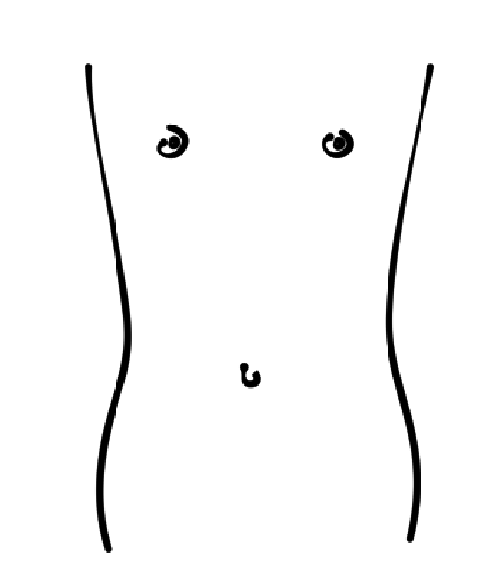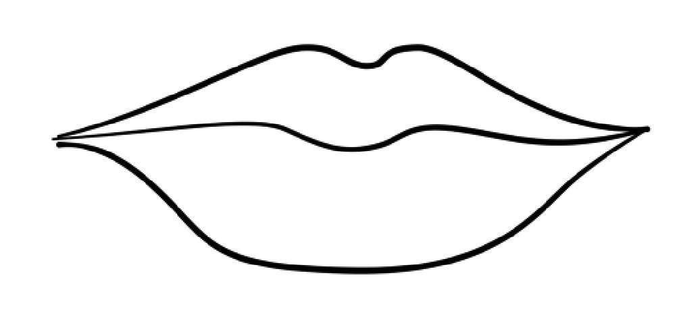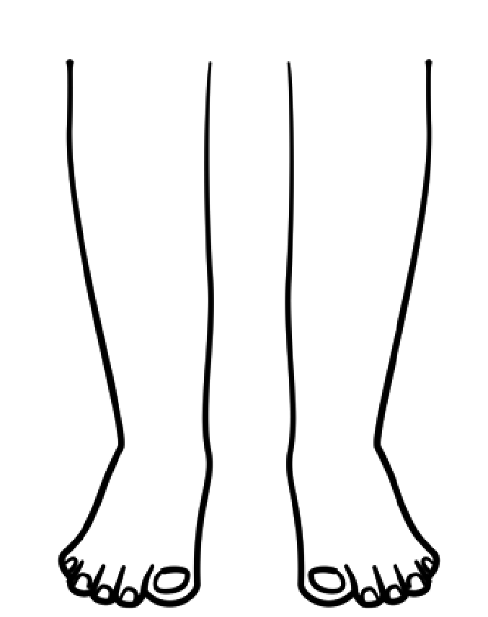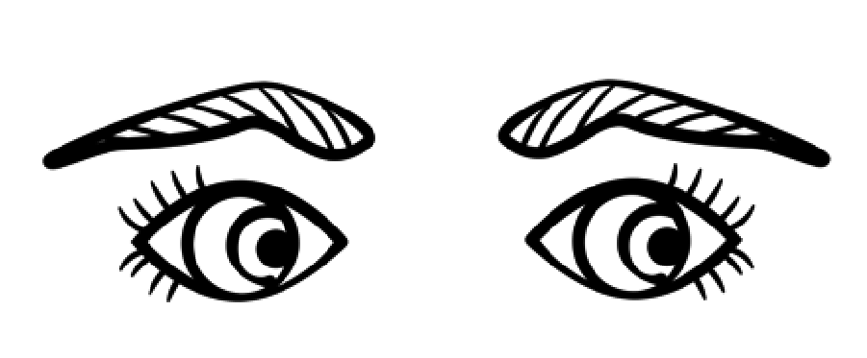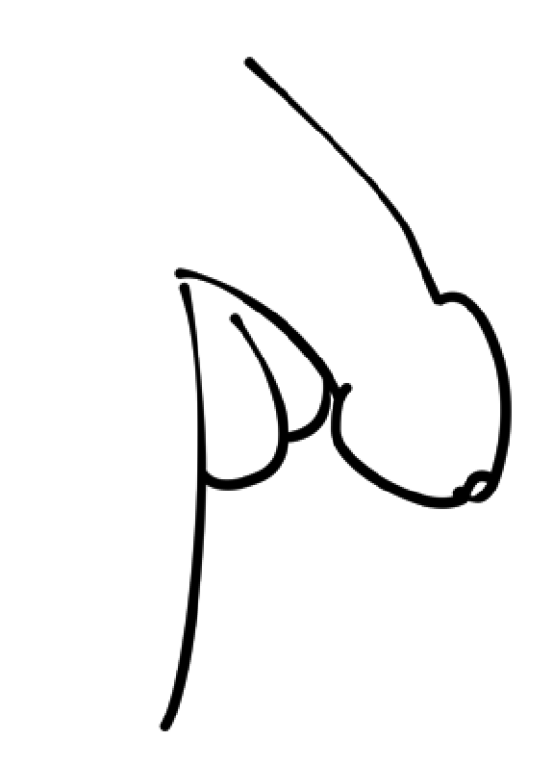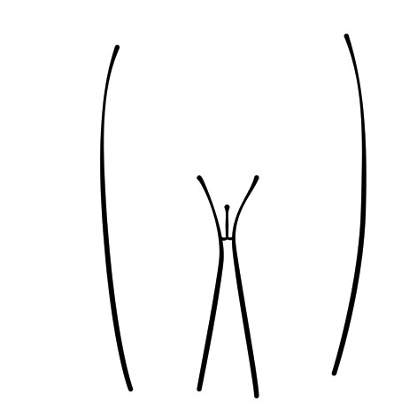

**Parent/Carer**

**copy**

**(**

**for**

**personal**

**use,**

**not**

**to**

**be**

**shared).**

**Copyright**

**©**

**PSHE**

**Association**

**2023**

**Parent/Carer**

**copy**

**for**

**(**

**personal**

**use,**

**not**

**to**

**be**

**shared).**

**Copyright**

**©**

**PSHE**

**Association**

**2023**

© Medway council 2022 **|** 20

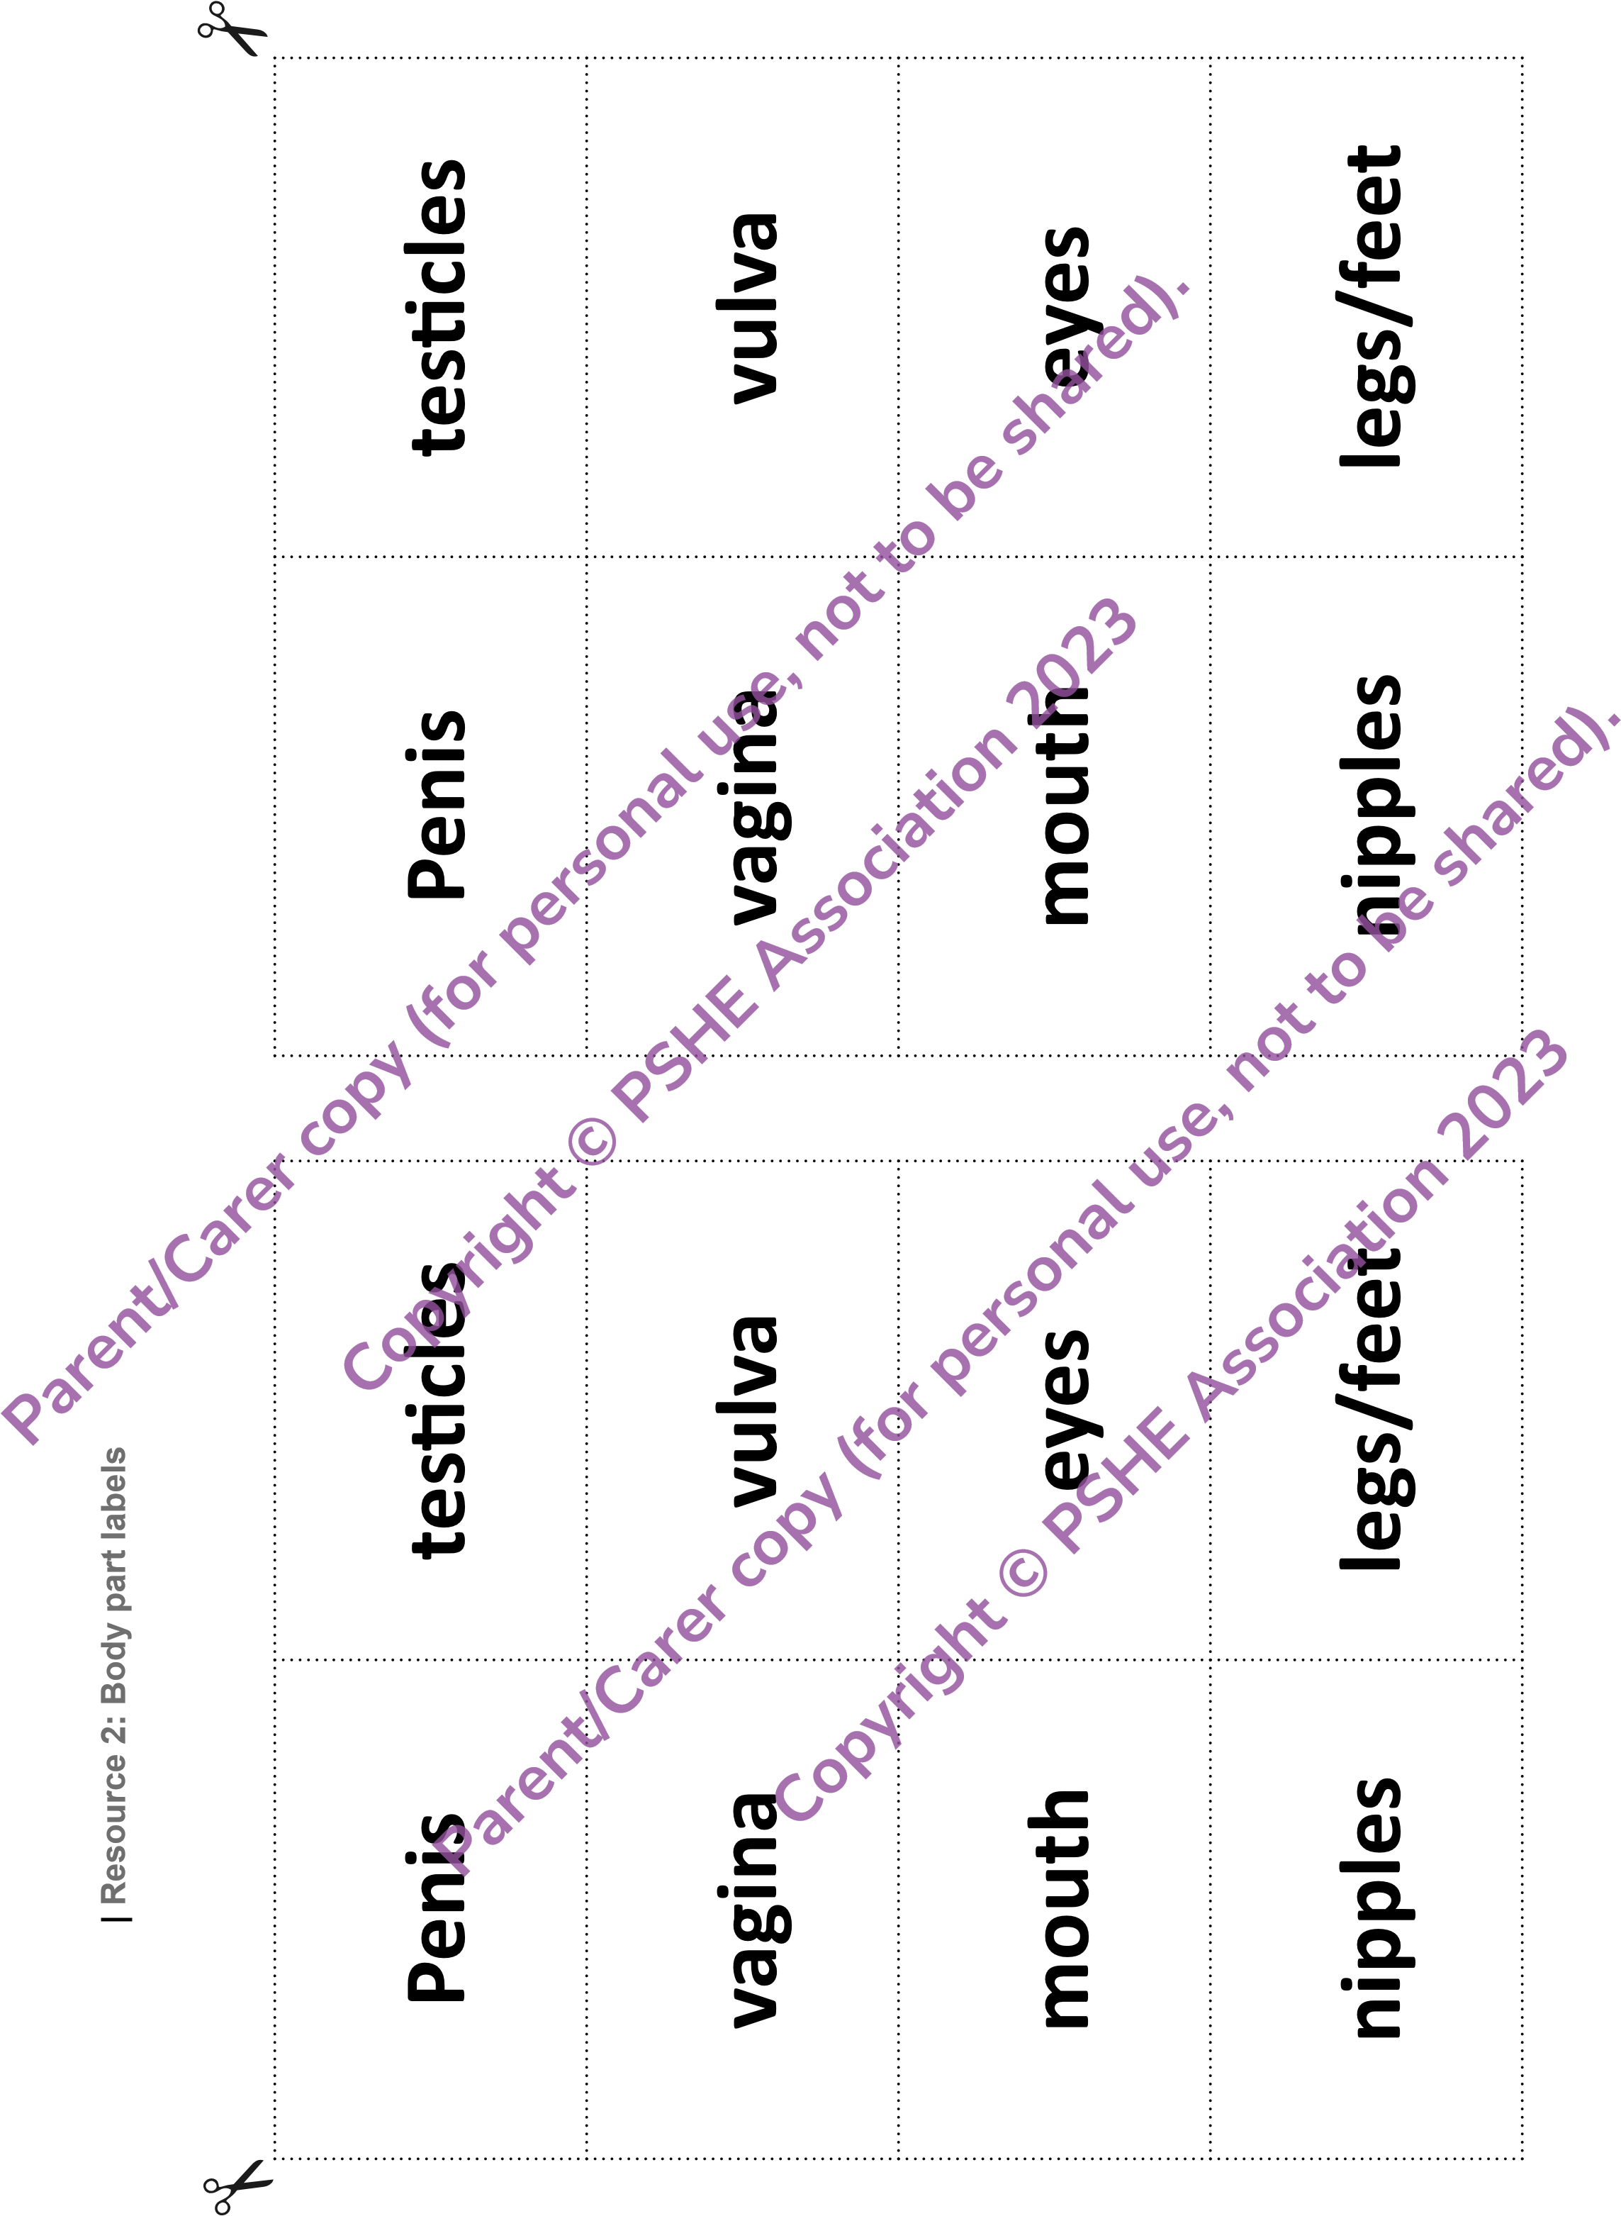

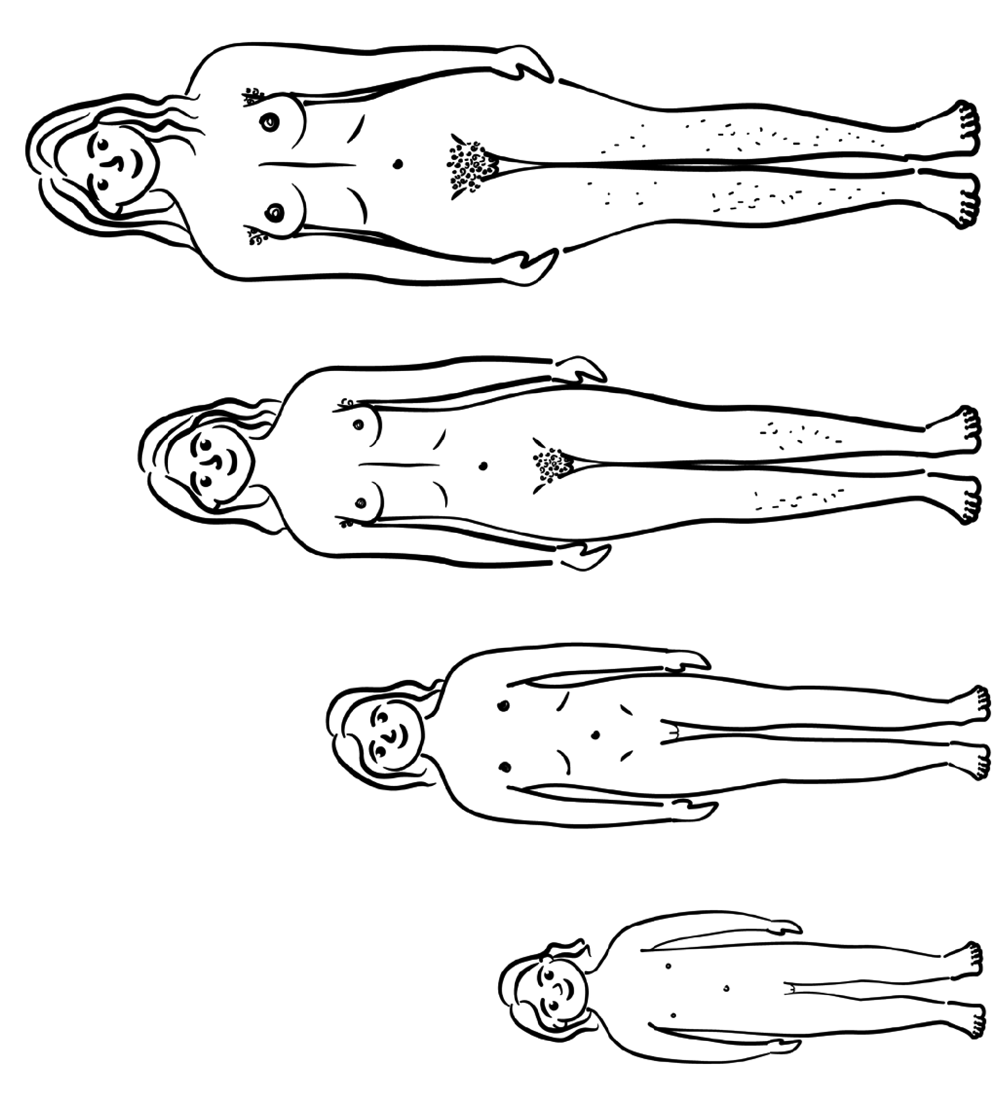

**Resource 3: Growing bodies**

**Parent/Carer**

**copy**

**for**

**(**

**personal**

**use,**

**not**

**to**

**be**

**shared).**

**Copyright**

**©**

**PSHE**

**Association**

**2023**

**Parent/Carer**

**copy**

**(**

**for**

**personal**

**use,**

**not**

**to**

**be**

**shared).**

**Copyright**

**©**

**PSHE**

**Association**

**2023**

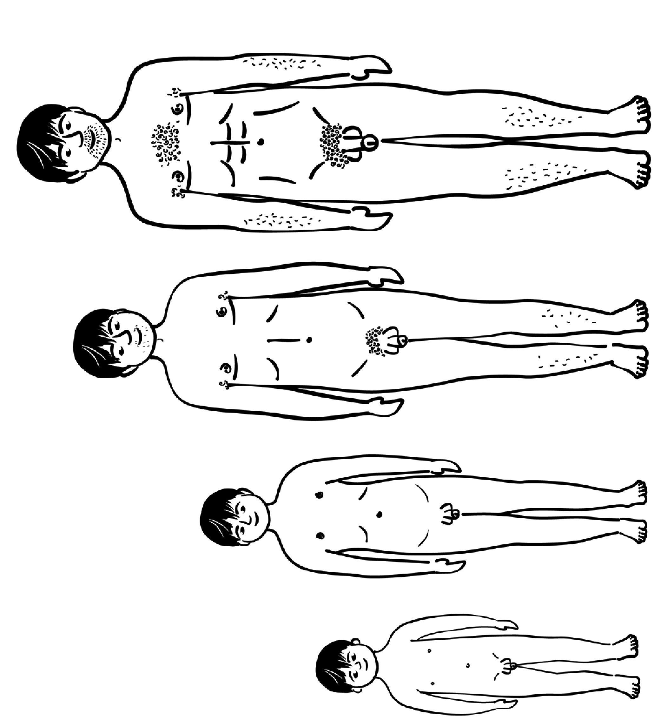

**Resource 3: Growing bodies**

**Parent/Carer**

**copy**

**for**

**(**

**personal**

**use,**

**not**

**to**

**be**

**shared).**

**Copyright**

**©**

**PSHE**

**Association**

**2023**

**Parent/Carer**

**copy**

**(**

**for**

**personal**

**use,**

**not**

**to**

**be**

**shared).**

**Copyright**

**©**

**PSHE**

**Association**

**2023**

© Medway council 2022

**|**

24

**Resource 4: Body changes Venn diagram**

**Female body changes**

**Male body changes**

**Both**

**Parent/Carer**

**copy**

**(**

**for**

**personal**

**use,**

**not**

**to**

**be**

**shared).**

**Copyright**

**©**

**PSHE**

**Association**

**2023**

**Parent/Carer**

**copy**

**(**

**for**

**personal**

**use,**

**not**

**to**

**be**

**shared).**

**Copyright**

**©**

**PSHE**

**Association**

**2023**

**Year 4-5 Lesson 1 Resource 4a: Body changes labels - support**

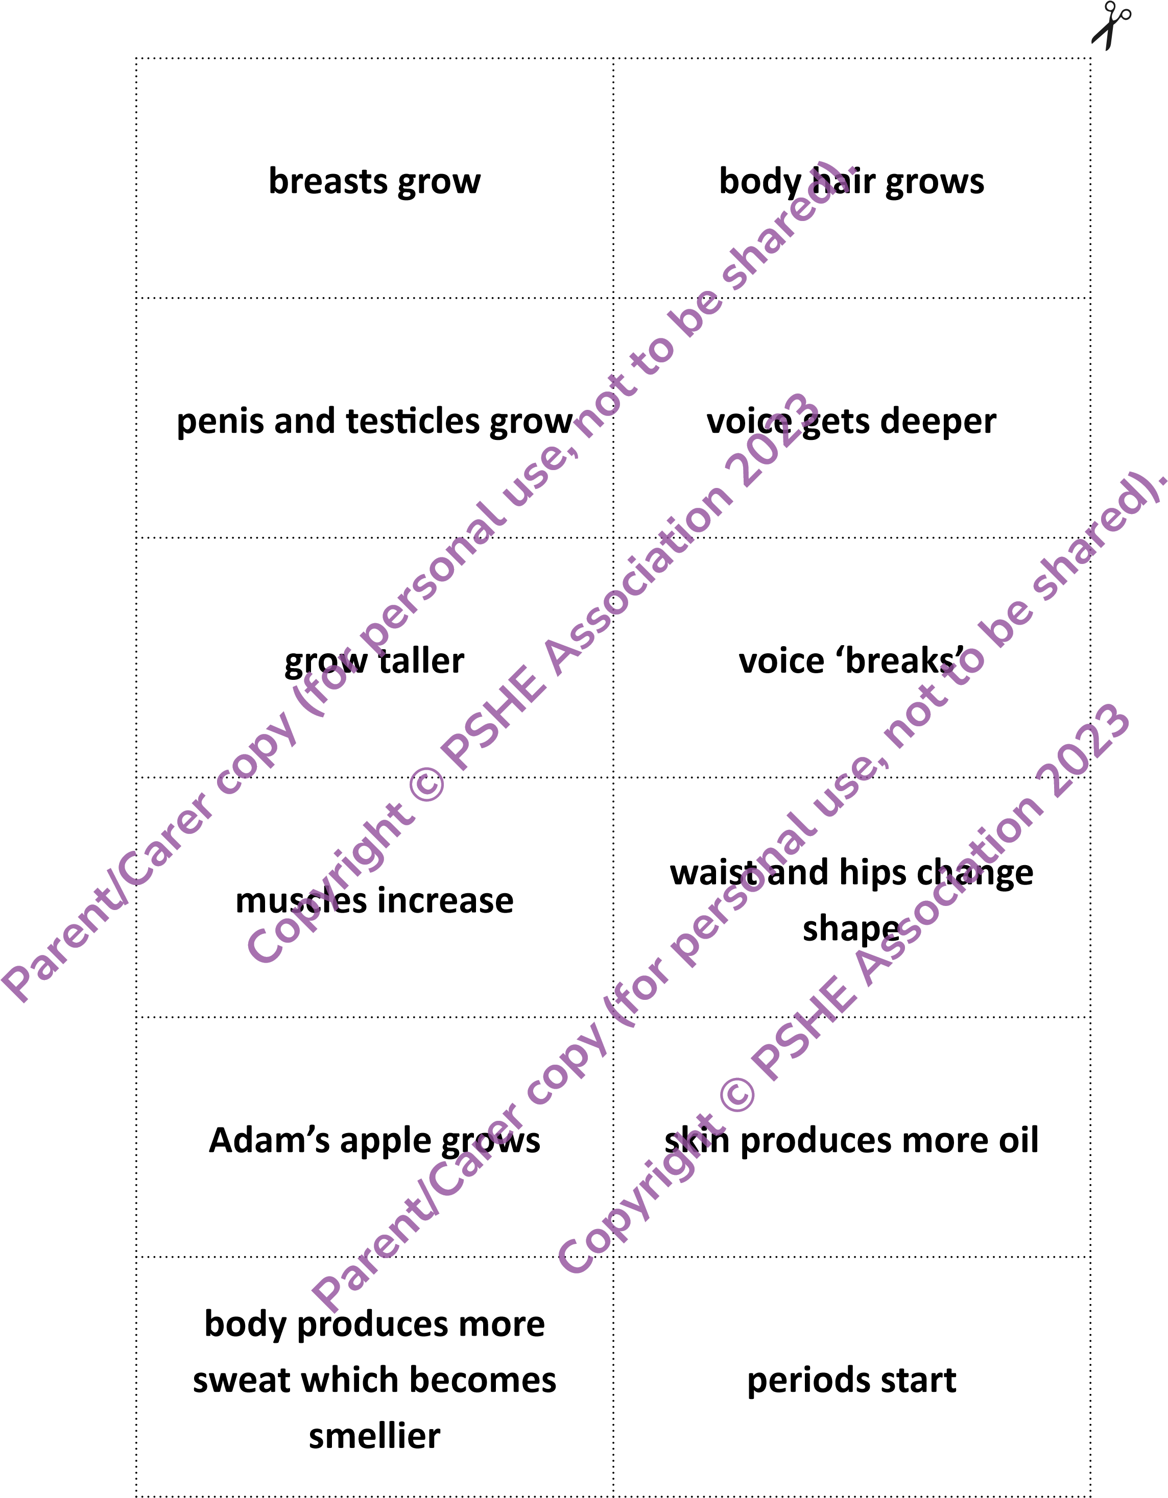

© Medway council 2022

**|**

26

**Year 4-5 Lesson 2**

**|**

**HVRXUFH)HPDOHERG\SDUWVLQFOXGLQJJHQLWDOLDDQGUHSURGXF**

**5**

**WLYHRUJDQV**

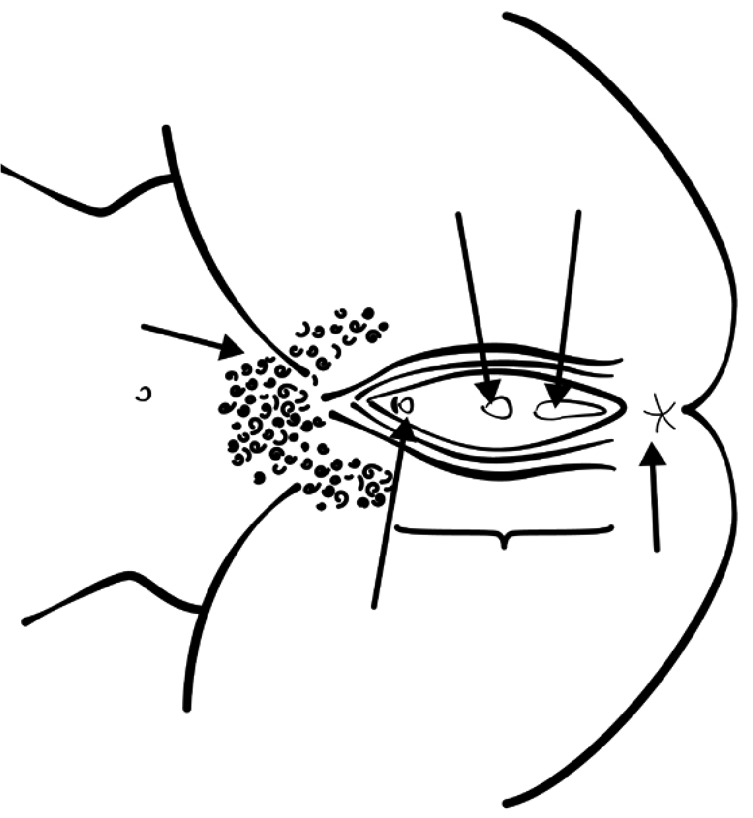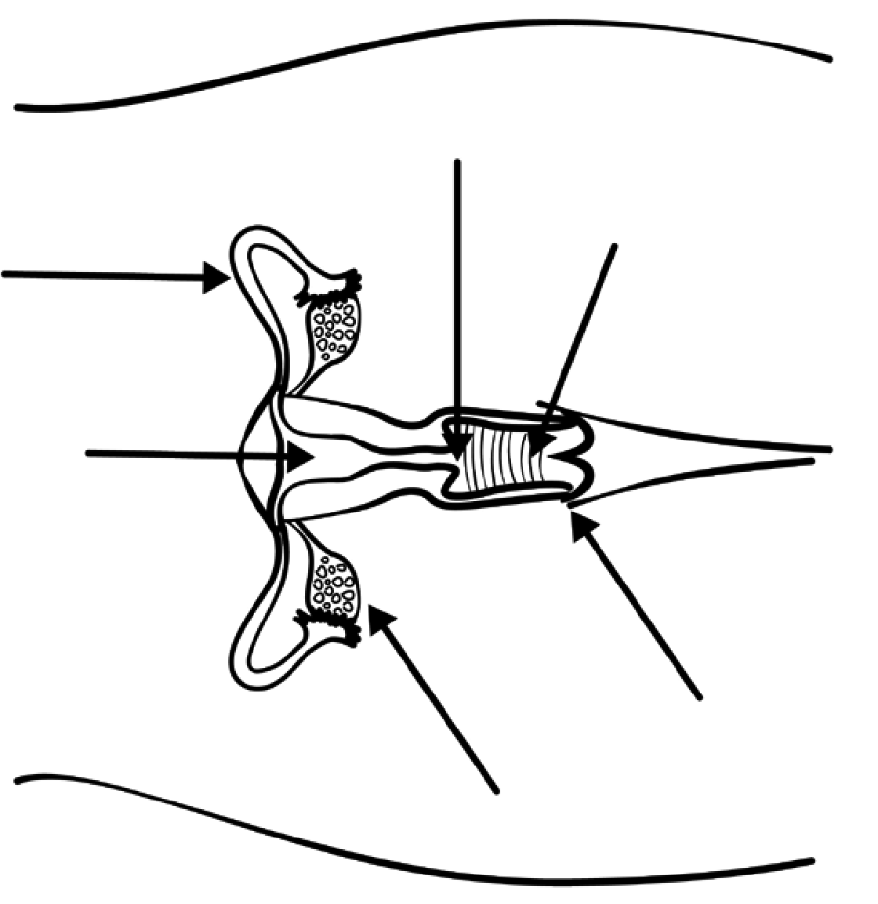

**Parent/Carer**

**copy**

**for**

**(**

**personal**

**use,**

**not**

**to**

**be**

**shared).**

**Copyright**

**©**

**PSHE**

**Association**

**2023**

**Parent/Carer**

**copy**

**for**

**(**

**personal**

**use,**

**not**

**to**

**be**

**shared).**

**Copyright**

**©**

**PSHE**

**Association**

**2023**

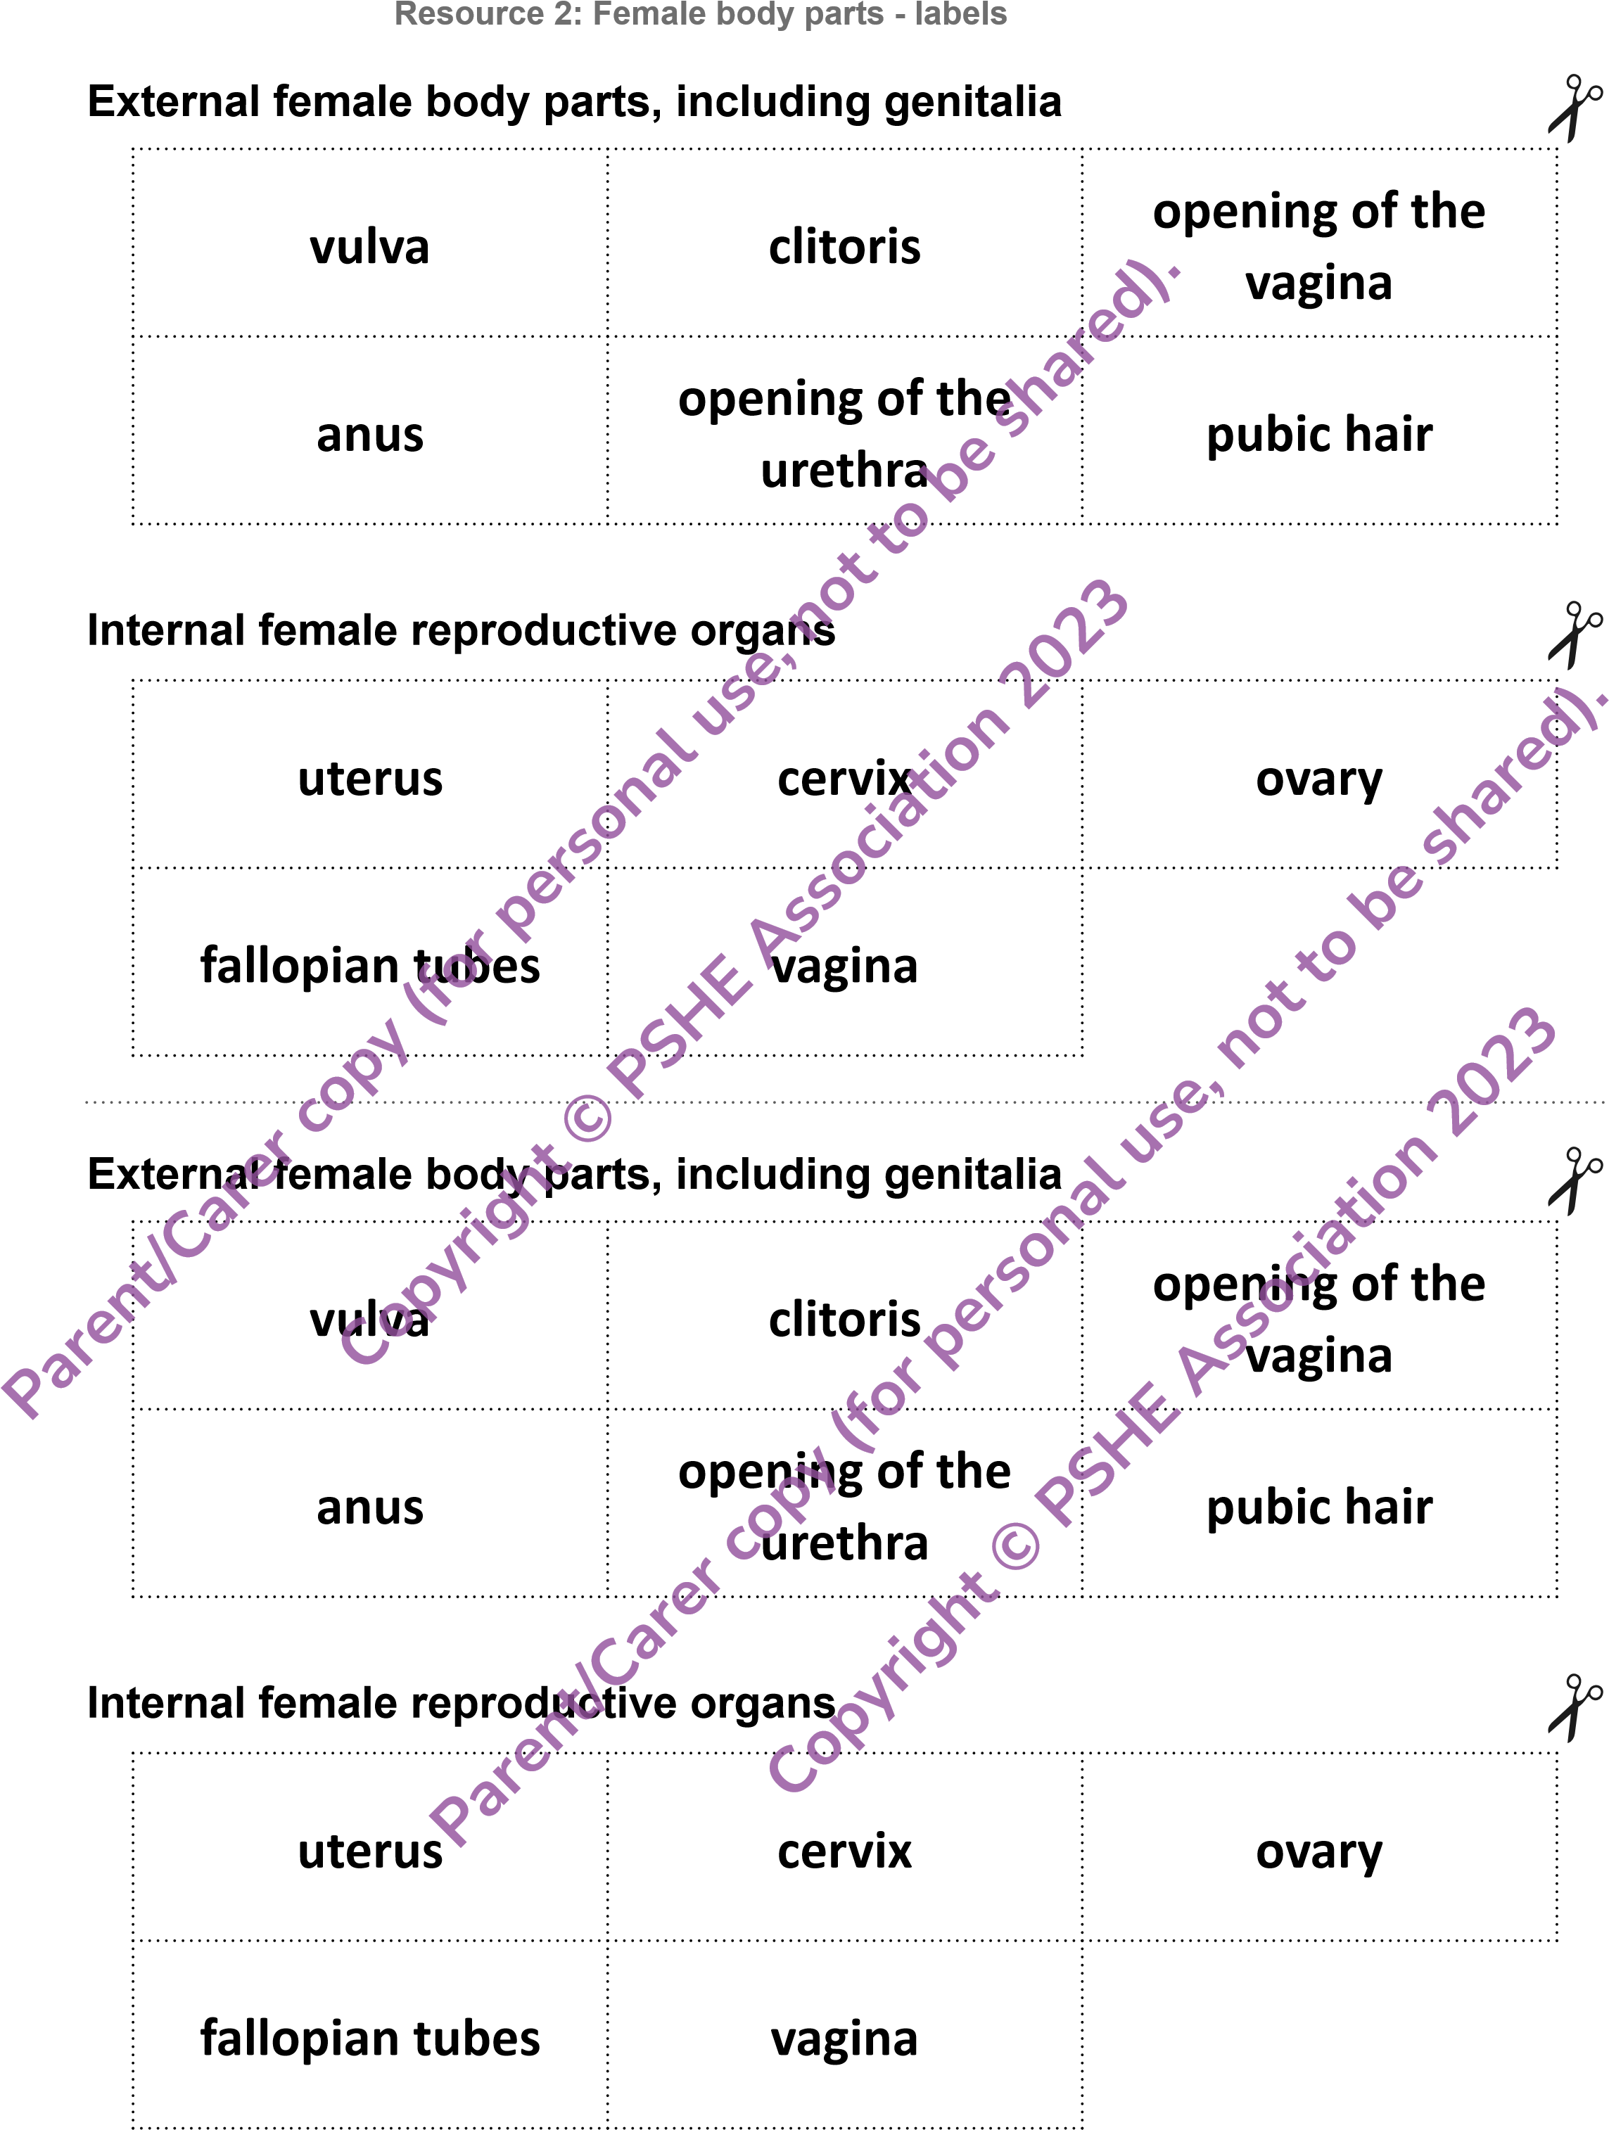

**Resource 3a: Menstrual cycle - support**

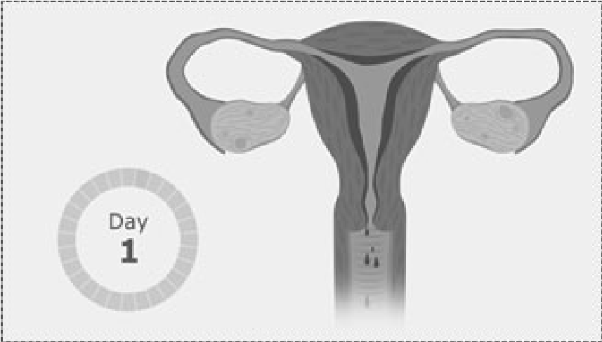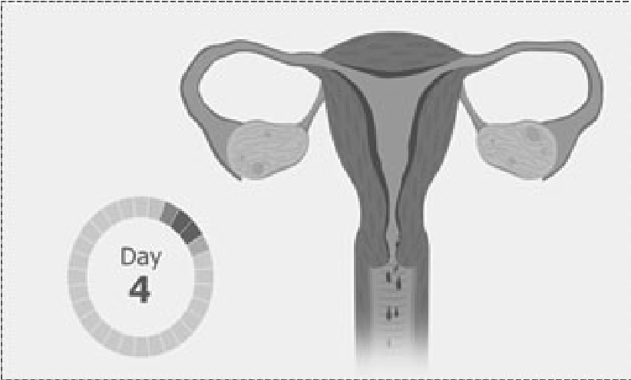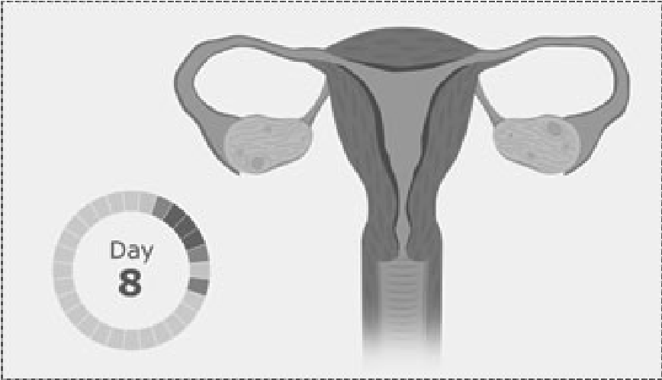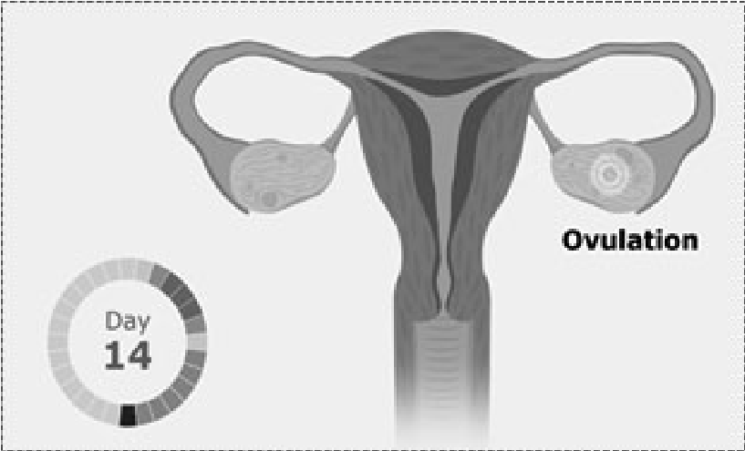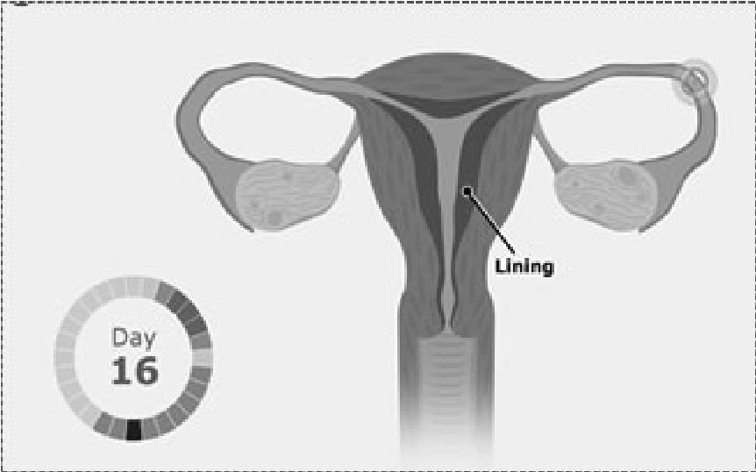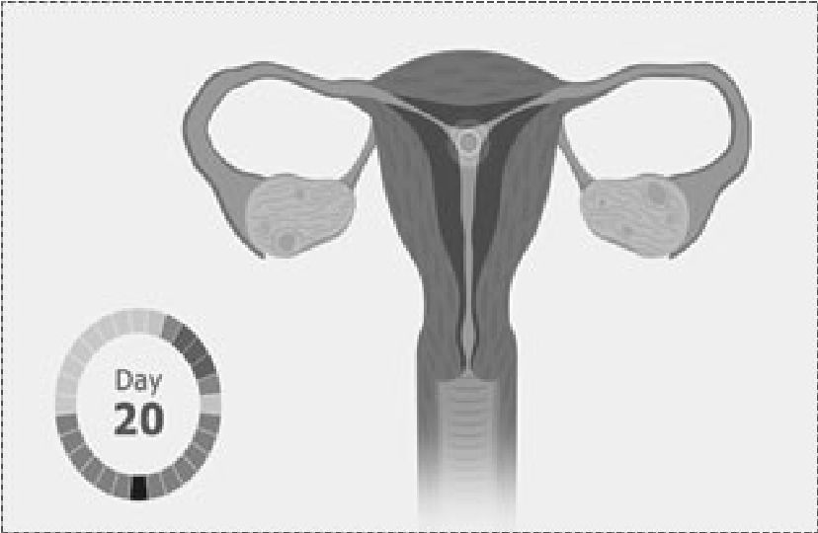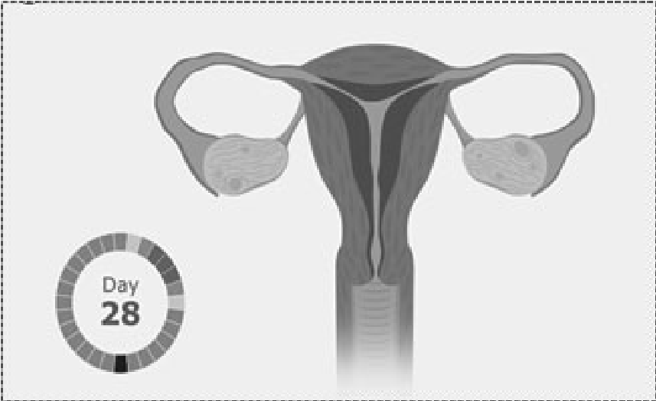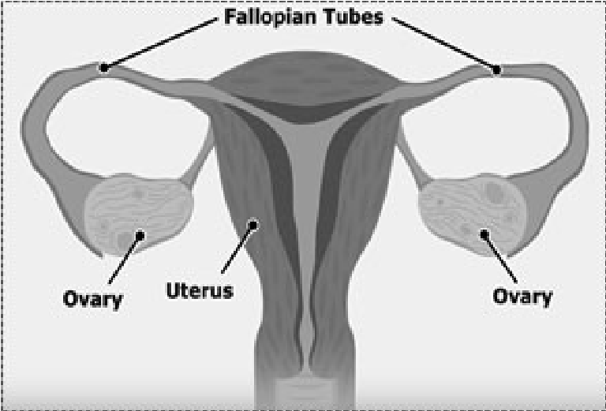

**Parent/Carer**

**copy**

**(**

**for**

**personal**

**use,**

**not**

**to**

**be**

**shared).**

**Copyright**

**©**

**PSHE**

**Association**

**2023**

**Parent/Carer**

**copy**

**for**

**(**

**personal**

**use,**

**not**

**to**

**be**

**shared).**

**Copyright**

**©**

**PSHE**

**Association**

**2023**

**Resource 4: Male genitalia and internal reproductive organs**

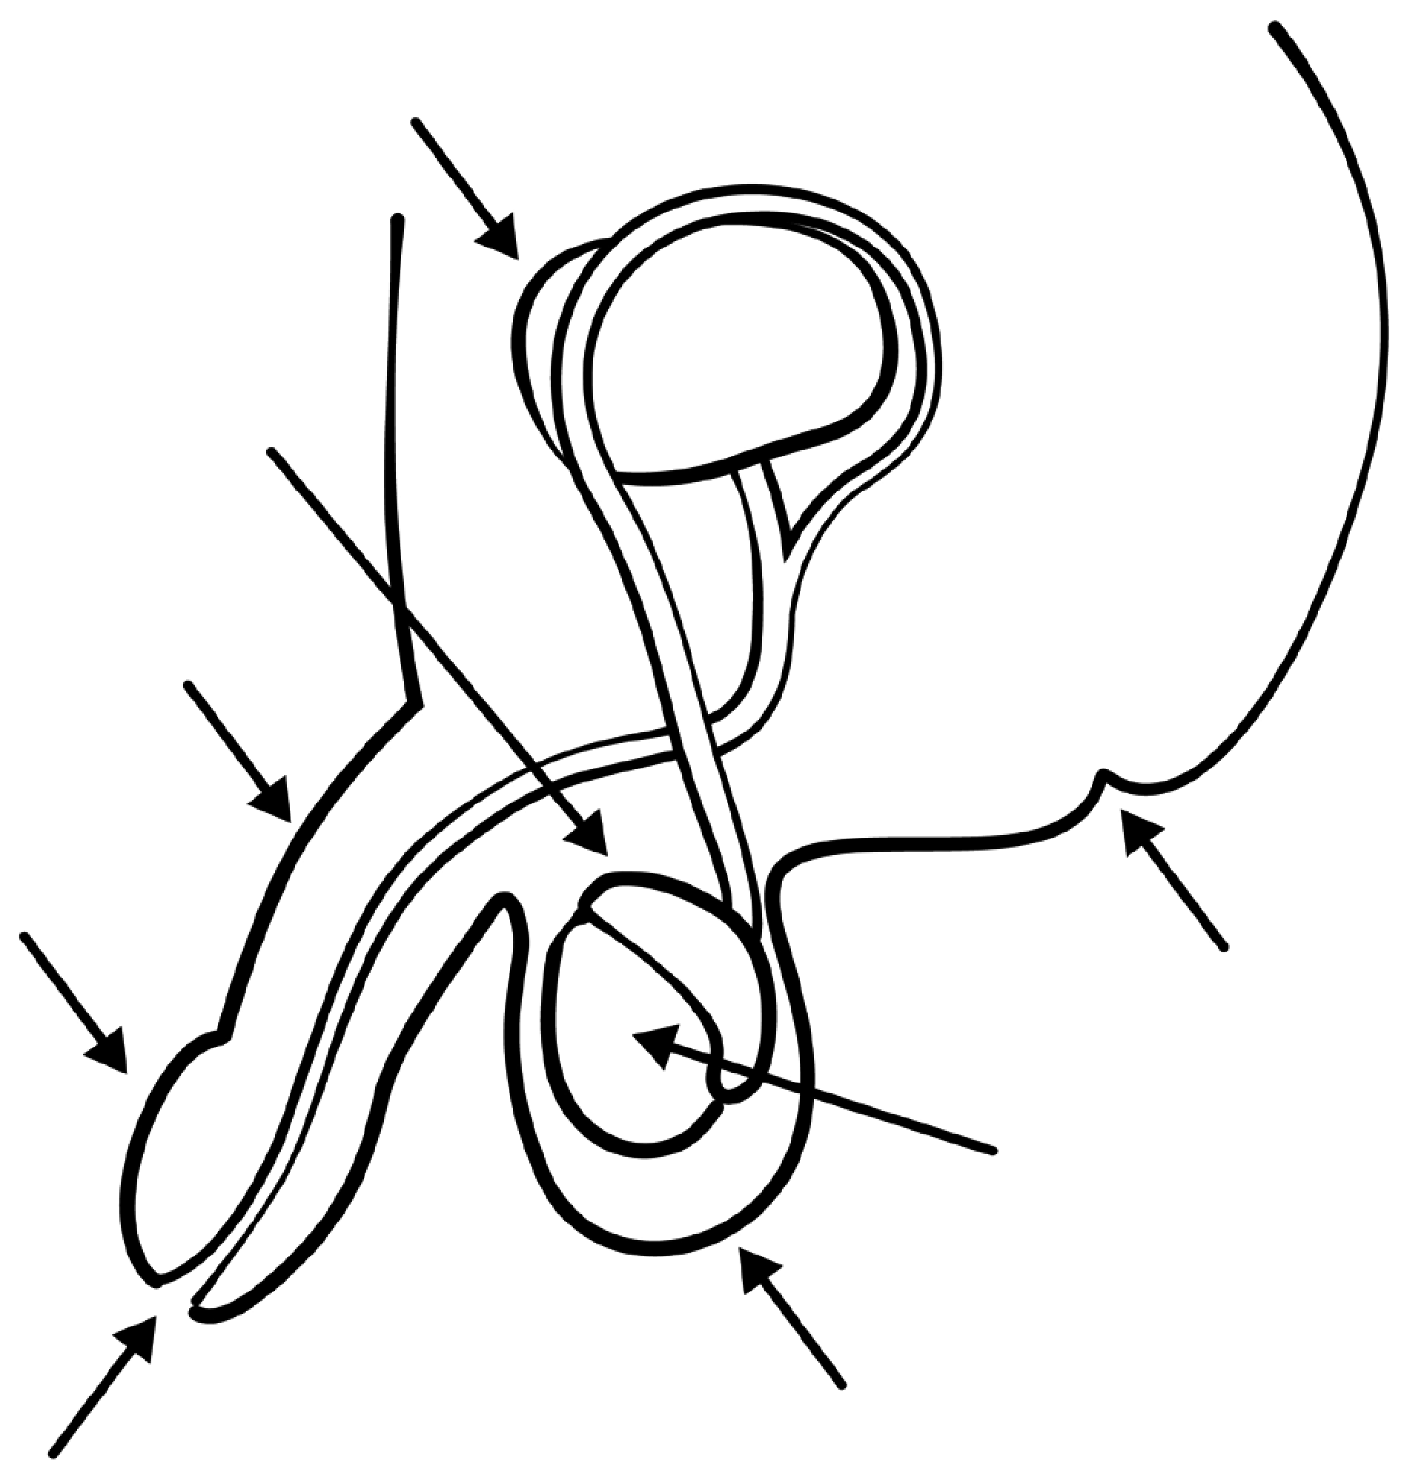

**Male genitalia and internal reproductive organ labels**

**bladder**

**penis**

**urethra**

**foreskin**

**scrotum**

**anus**

**epididymis**

**ƚĞƐƟĐůĞ**

**Parent/Carer**

**copy**

**(**

**for**

**personal**

**use,**

**not**

**to**

**be**

**shared).**

**Copyright**

**©**

**PSHE**

**Association**

**2023**

**Parent/Carer**

**copy**

**(**

**for**

**personal**

**use,**

**not**

**to**

**be**

**shared).**

**Copyright**

**©**

**PSHE**

**Association**

**2023**

|  |  |
| --- | --- |
| **Hair** | **Why:**  ƵƌŝŶŐƉƵďĞƌƚǇ͕ŚĂŝƌďĞĐŽŵĞƐ  ŽŝůŝĞƌ͘  **How:**  tĂƐŚŝŶŐŚĂŝƌǁŝƚŚǁĂƌŵǁĂƚĞƌ  ĂŶĚƐŚĂŵƉŽŽ͘  **,ŽǁŽŌĞŶ͗**  ZĞŐƵůĂƌůǇ͘  **be**  **shared).** |
| **Armpits**  **personal**  **use,**  **not** | **Why:**ƵƌŝŶŐƉƵďĞƌƚǇ͕ŵŽƌĞƐǁĞĂƚŝƐ ŵĂĚĞ͕ĂŶĚŝƚĐĂŶŵĂŬĞĂƌŵƉŝƚƐƐŵĞůů͘  **How:**tĂƐŚŝŶŐĂƌŵƉŝƚƐǁŝƚŚƐŽĂƉ or shower gel, using deodorant and ǁĞĂƌŝŶŐĐůĞĂŶĐůŽƚŚĞƐ͘ **,ŽǁŽŌĞŶ͗**ǀĞƌǇĚĂǇ͘  **to**  **sociation**  **2023** |
| **Feet**  **copy**  **(**  **for**    **Copyright**  **©**  **PSHE**  **As** | **Why:**  ƵƌŝŶŐƉƵďĞƌƚǇ͕ŵŽƌĞƐǁĞĂƚŝƐ  ŵĂĚĞĂŶĚĐĂŶŵĂŬĞĨĞĞƚƐŵĞůů͘  **How:**  Bathing or showering and  ǁĞĂƌŝŶŐĐůĞĂŶƐŽĐŬƐ͘  **,ŽǁŽŌĞŶ͗**  ǀĞƌǇĚĂǇ͘      **personal**  **use,**  **not**  **to**  **be**  **Association** |
| **Genitals (vulva)**  **Parent/Carer**  **cop**  **y** | **Why:**dŽƐƚŽƉƐĞĐƌĞƟŽŶƐďƵŝůĚŝŶŐƵƉ  ĂŶĚďĞĐŽŵŝŶŐƐŵĞůůǇ͕ŝƚĐŚǇŽƌƐŽƌĞ͘  **How:**hƐŝŶŐũƵƐƚǁĂƚĞƌŽƌƵŶƉĞƌĨƵŵĞĚ soap to wash the area around the ǀƵůǀĂ͘  **(**  **for**    **opyright**  **©**  **PSHE**  **,ŽǁŽŌĞŶ͗**ǀĞƌǇĚĂǇ͘ |
| **C**  **Genitals (penis**  **ĂŶĚƚĞƐƟĐůĞƐͿ** | **Why:**dŽƐƚŽƉƐĞĐƌĞƟŽŶƐďƵŝůĚŝŶŐƵƉ͕ ǁŚŝĐŚĐĂŶďĞĐŽŵĞƐŵĞůůǇŽƌŝŶĨĞĐƚĞĚ͘  **How:**hƐŝŶŐƉůĂŝŶ͕ŵŝůĚƐŽĂƉƚŽǁĂƐŚ ƚŚĞƉĞŶŝƐĂŶĚƚĞƐƟĐůĞƐ͘/ĨƚŚĞƉĞŶŝƐŚĂƐ ĂĨŽƌĞƐŬŝŶ͕ĐůĞĂŶŐĞŶƚůǇƵŶĚĞƌŶĞĂƚŚ͘  **,ŽǁŽŌĞŶ͗**ǀĞƌǇĚĂǇ͘ |

**Year 4-5 Lesson 3 Resource 1: Personal hygiene labels - support**

**shared).**

**2023**

**Parent/Carer**

**Year 4-5 Lesson 3**

**Resource 2: Hygiene questions**

**What is personal hygiene?**

**Is it OK to swim when having a period?**

**,ŽǁŽŌĞŶƐŚŽƵůĚƐŽŵĞŽŶĞǁĂƐŚĚƵƌŝŶŐƉƵďĞƌƚǇ͍**

**Why is it important to change clothes regularly?**

**How can someone manage body odour?**

**Parent/Carer**

**copy**

**(**

**for**

**personal**

**use,**

**not**

**to**

**be**

**shared).**

**Copyright**

**©**

**PSHE**

**Association**

**2023**

**Parent/Carer**

**copy**

**for**

**(**

**personal**

**use,**

**not**

**to**

**be**

**shared).**

**Copyright**

**©**

**PSHE**

**Association**

**2023**

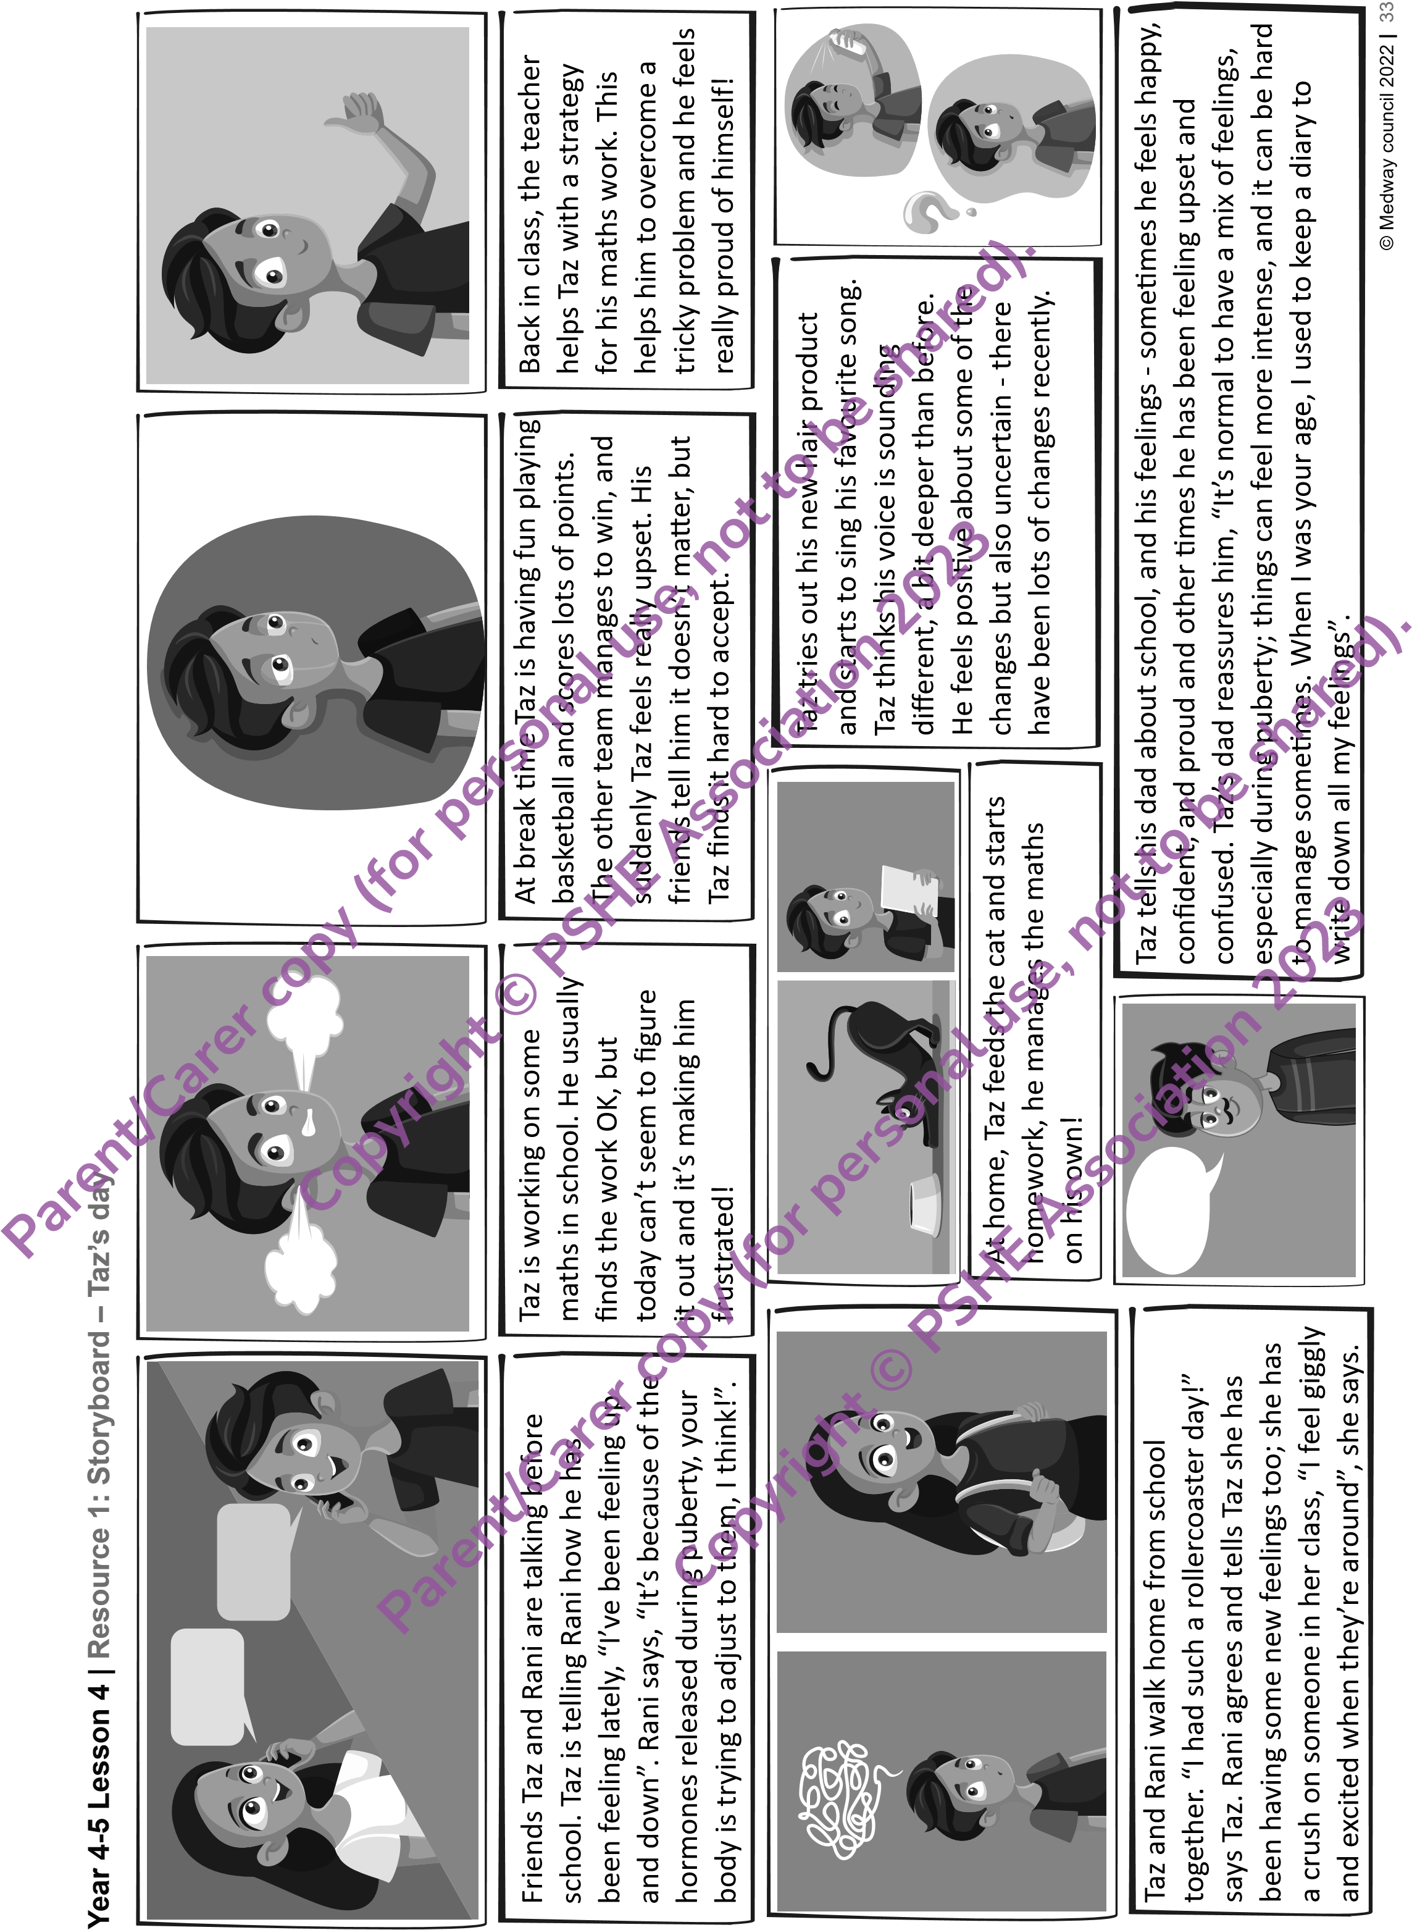

**Year 4-5 Lesson 4 | Resource 2: Emotions and feelings**

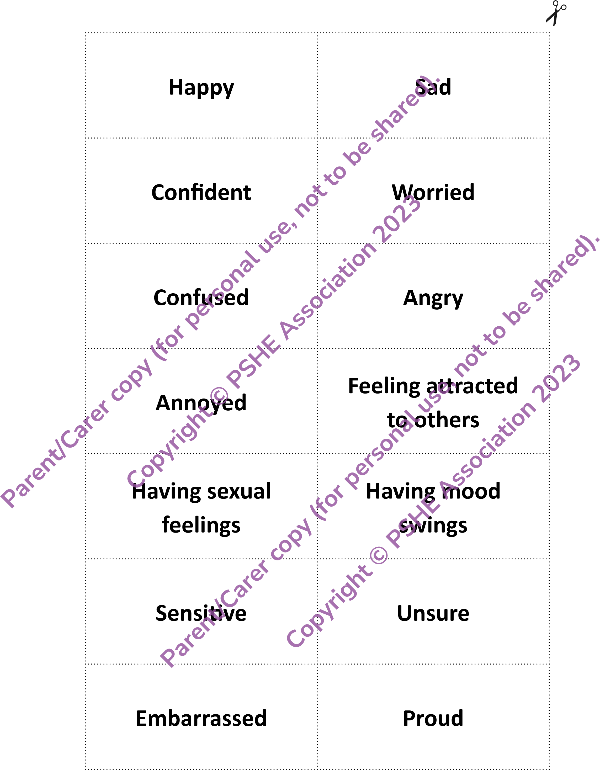

© Medway council 2022 **|** 34